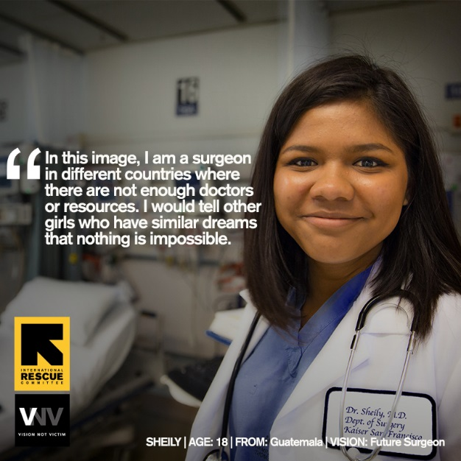

Dear Vision Project Supporters,

The refugee crisis may have dominated the news for several years, but thanks to your generous support the IRC is empowering refugees, and especially refugee girls, to tell the world a new story – one of freedom and hope. The stories and the images are incredibly inspiring. When Rocio, a 16-year-old from El Salvador, saw the picture of herself as a future immigration lawyer she shared, “I am a strong and powerful woman, and I can do everything I want. Nothing is impossible in our life. If we want we can do it, we can try… You can make everything real if you have a dream, just never give up.”

The Vision Project, a week-long workshop, culminates in photo shoots with each girl as they step into their future selves. These photographs not only remind the girls of their potential, they also have the powerful capacity to change public perceptions of refugees on a broader scale. These girls are not merely victims of tragic circumstances – they are our future engineers, teachers, lawyers, social activists, and ocean explorers – and their stories should be told.

We have run three cohorts of the Vision Project over the past 18 months. During these, 36 girls participated, from 14 different countries and speaking 7 different languages.
They envisioned 20 different careers, from doctors and law enforcement officers, to dentists, pilots and rock singers.

The program was staffed by two facilitators, several interpreters, and a logistics coordinator. In addition, we have brought in professional photographer Meredith Hutchison and gender equity youth facilitator Aisha Bain. These two founded Vision Not Victim, the original project, which was run overseas. Their roles have been critical in developing a strong curriculum and exceptional photographs that capture the essence of these girls and their dreams for a future as women in America.

We are immensely grateful for strong community partnerships that have helped make this project possible, from the amazing contributions of Presbyterian churches underwriting the program and offering venues, to individual supporters making financial donations, supplying lunches and volunteering transportation help, to in-kind support from companies like Airbnb, who offered their headquarters in San Francisco for an on-site experience during the camp.

This program has a budget of approximately $25,000 per run. IRC Nor Cal has raised over $75,000 to make this possible, 100% through direct community giving. With your additional support for transportation, food and supplies, we have been able to set the cost per girl at $1,500 per run.

A designated online landing page has just gone live allowing donations directly to the project. We plan a fourth run in the Spring of 2019. If you have a space where you would be interested in hosting a display of the photos or wish to set up a time to share the project with an interested group, please contact us at Vision.Project@rescue.org.

We would love to count on your continued generous support for the Vision Project workshops that we are planning for 2019.
https://help.rescue.org/donate/us-northern-California-vision-project#

If you would like additional information about our work, please do not hesitate to contact us. Vision.Project@rescue.org

