Race Equity Audit

Final Report

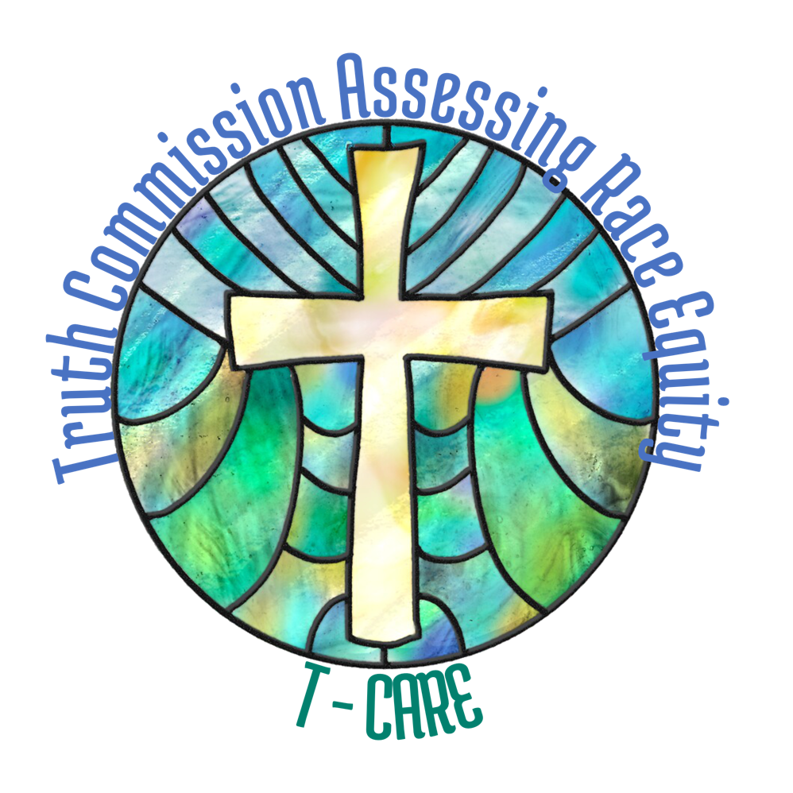

Truth Commission Assessing Race Equity

Presbytery of San Francisco

February 2025

Table of Contents
Preamble 1
Key Definitions 2
Context and History 3
Themes and Patterns 4
Strategic Recommendations 12
Acknowledgments 16
Appendix 1. Continuum Tool Analysis 19
Appendix 2. Matrix Narrative 29
Appendix 3. Summary of Race Equity Survey 38
Appendix 4a. Courageous Agreements: Short Form 57
Appendix 4b. Courageous Agreements: Long Form 58
Appendix 4c. Courageous Agreements Litany 60
Appendix 5. Kaleidoscope Agreements 61
Appendix 6a. Case Study: Hillside Presbyterian Church Closure 62
Appendix 6b. Case Study: Primera Iglesia Presbiteriana Hispana & High Street Presbyterian 77
Appendix 6c. Case Study: South Hayward Parish – Property Use/Sale/Lease 90
Appendix 7. Abbreviations 98
Appendix 8. Conversation Circle Summary Notes 99

Preamble
The Presbytery of San Francisco (PSF) readily accepted the call to become a Matthew 25 presbytery, “Truly I tell you, just as you did it to one of the least of these brothers and sisters of mine, you did it to me.” (Mt 25:40). This keystone verse encourages us in our times of need to feel the full dignity of Christ as he identifies with us. The verse also challenges us in our times of strength to be generous to others as we would to Christ, seeing Christ in those around us. Thus Jesus invites us to create a community of mutual service, free from hierarchy:

But you are not to be called rabbi, for you have one teacher, and you are all brothers and sisters. And call no one your father on earth, for you have one Father, the one in heaven. Nor are you to be called instructors, for you have one instructor, the Messiah. The greatest among you will be your servant. All who exalt themselves will be humbled, and all who humble themselves will be exalted. (Mt 23:8-12)

The Presbytery acknowledges these calls to equality and mutuality. But hierarchy is baked into the way we function. Even when people do not appear to “lord it over” one another in an explicit sense, still our close study of the PSF yielded an image of insiders and outsiders, people in inner circles who feel a sense of belonging and empowerment and access to resources while others find themselves at the margins feeling like they are “other” and not valued members of a community. The circles of “othering” and belonging in our presbytery may appear subtle to some, but they are glaringly obvious to others. Those in the center may be unaware; those at the margins may be painfully aware.

"Eli said, “What was it that he told you? Do not hide it from me. May God do so to you and more also, if you hide anything from me of all that he told you.” So Samuel told him everything and hid nothing from him. Then he said, “It is the Lord; let him do what seems good to him.” (1 Samuel 3:17-18)

This report seeks to “hide nothing” from us, and to make it plain for all to see the circles of othering and belonging that perpetuate and exacerbate racial inequities. We, the Truth Commission Assessing Race Equity (T-CARE), dare to name a positive vision for our future:
- A presbytery with full participation and effective representation in all decisions.
- A presbytery that understands its history and the context in which we live.
- A presbytery that has named and healed from past harms.
- A spiritual community where people feel they belong.

We know that to reach this vision we must enact a cultural shift. The entire organization must shift to a more relational model where we prioritize “being” over “doing,” where we run as a community rather than a business, where people of all races, cultures, identities, languages, and backgrounds are essential community members.

Our hope is that by naming where racism is operating in our presbytery, together we can move our vision forward. We humbly acknowledge that we will not name all those ways that racism operates. Yet, our work represents a faithful effort to uncover what we have discovered in our presbytery's written record. We know that the written record only holds a portion of our experience and must be just the tip of the iceberg. We will invite you to share your experiences to add depth and breadth to T-CARE's findings.

The Presbyterian Church (USA) Book of Order (BOO) calls us to embrace a new openness to God’s mission in the world: “a new openness in its own membership, becoming in fact as well as in faith a community of all people of all ages, races, ethnicities, abilities, genders, and worldly conditions, made one in Christ by the power of the Spirit, as a visible sign of the new humanity.” (BOO F-1.0403, emphasis added). Our church is “a community of all people” in faith, but not yet in fact. We ask for the Spirit’s help to become “a visible sign of the new humanity.”

Key Definitions
- Race: a social construct based on skin color that operates to install hierarchies of oppression and benefits.
- Racism: race-based prejudice plus institutional power.
- Black/Indigenous/People of Color: there are a number of ways that people of color identify by race. Sometimes in this report we will identify a group of people more specifically, but we will also use Black/Indigenous/People of Color (BIPOC) in this report. We recognize the limitations of language, the insufficiency of recognizing the identities of others, the flattening inherent in such a wide blanket label, and always recognize people’s right to self-identify as they choose.
- Repair/Reparative Action: an orientation towards prioritizing fixing inequities caused by persisting racism with justice and reallocation of stolen resources.
- Reparations: specific acts of reparative action intended to restore intergenerational wealth taken by discrimination, often through the power of the government.
- White Supremacy: a system of beliefs and attitudes that subtly or explicitly more highly esteem those racialized as White and continue to grant advantages.
- Internalized White Supremacy: the acceptance of the negative societal beliefs and stereotypes about marginalized racial and ethnic populations by themselves and white persons, and the different impacts on their self-identity.
- White Supremacy Culture: consciously and unconsciously valued norms, behaviors, and practices originally created by white, wealthy, Christian, European men to maintain power over resources and other people.
- Antiracism: Actively opposing racism by advocating for changes in our political, economic, and social life. Institutions start their antiracism journey by understanding how they participate in and are integral to white supremacy, and by providing spaces of reflection for individuals to interrupt behaviors that sustain white supremacy culture.
- Race equity: a process of eliminating racial disparities and improving outcomes for everyone; the intentional and continual practice of changing policies, practices, systems, and structures by prioritizing measurable change in the lives of people of color.
- Othering: a frame that captures the many forms of prejudice and persistent marginality such as race, gender, sexuality, religion, income, and disability. Also applies to a set of common policies and practices that engender othering.
- Belonging: more than just being seen or feeling included, belonging entails having a voice and the opportunity to use it to make demands upon society and political institutions. Belonging is more than having access; it is about the power to co-create the structures that shape a community.6

Context and History
The Presbytery of San Francisco was founded in 1849 by white settlers and mission workers sent from churches and presbyteries from the eastern part of the United States. All presbyters were white men at the founding of the Presbytery, but multiracial outreach began shortly and the first Chinese-American congregation was established in 1853. No ministry to or with any Native American people is noted in our early history; the Presbytery benefited economically from the dispossessing of Ohlone people from their land which was then available for purchase at very low prices. For many years the Presbytery and its congregations were dependent on financial contributions from back East; a vivid example is that one congregation had a church building constructed in New York and shipped around Cape Horn to be erected in San Francisco.

Over the following 175 years some congregations founded by and for white people remained strongly white-dominant, even despite the increasing diversity of the Bay Area. Other congregations became more inclusive in varying degrees: some engaging in deliberate multiracial ministry, others adopting symbolic levels of inclusion while remaining significantly white-dominant. Other congregations that had been exclusively white in some cases experienced dramatic demographic change as redlining laws gave way to equal housing opportunities, followed by “white flight” to the suburbs; some formerly white-dominant urban congregations then became communities of belonging for BIPOC. There are many stories here that deserve to be told, and we know there are stories of great faith and service as well as more difficult stories of racialized conflict in the congregations of our presbytery.

We are a diverse presbytery compared to others in the 92% white PC(USA). Based on the 2022 statistical report, and with adjustments made by the Clerk for non-reporting congregations, we calculated that our presbytery membership is 73% white, 15% Asian, 6% African American, 3% Hispanic/Latina/Latino/Latinx, 3% multi-racial. Together we worship in nine languages, and we are proud of this. We celebrate the vibrance of our worshiping communities as if it were evidence of the anti-racist virtue of the institution. Yet, there are significant patterns of inequity that show our multicultural identity to be mainly symbolic. And even though we are diverse compared to presbyteries elsewhere in the nation, we are in a much more diverse Bay Area; according to the Bay Area Equity Atlas, our neighborhoods are 36% white, 27% Asian, 23% Hispanic/Latina/Latino/Latinx, 7% African American, and 6% multi-racial. The Presbytery has not served all the people of the area but has maintained a strongly white center.

Themes and Patterns
These themes and patterns were identified by the T-CARE team as we studied the Presbytery. We began by studying the written record to identify key themes. We then applied Crossroads’ Continuum and Matrix Tools (Appendix 1 and 2, respectively). We also surveyed the Presbytery; survey responses will be woven through this analysis as well as available in Appendix 3. We also completed three case studies to document how racism is operating within our Presbytery.

Insiders and Outsiders
We confess and believe that the Presbytery is “the people” but there is not a strong sense that this feels true. The Presbytery is experienced as a community of belonging for some, but more people experience the Presbytery as an impersonal set of formal processes.
The survey team was surprised at some positive responses about belonging: 58% of respondents agreed “I feel welcome to participate and to make my contribution to the presbytery,” and 56% agreed “I feel at ease in our presbytery.” From our analysis of the Presbytery we expected these results might have been lower, and we suspect some selection bias may affect the questions (those who did not feel welcome may have chosen not to take the survey). We also discovered that only 20% of respondents who identified as attending immigrant worshipping communities said they feel welcome.

Perhaps more telling is the statement “I am heard, and my voice matters to the presbytery.” Less than half agreed (47%) and more than half (53%) either didn’t agree or didn’t know.
Several factors may contribute to disparities in who feels a sense of belonging and mattering.

We might ask what metaphors are used to talk about presbytery relationships. Some may use close and mutual metaphors such as “siblings in Christ,” and may truly feel the familiarity implied. We also heard metaphors of extended family: “we would only see them at the funeral of a pastor.” We also heard paternalistic metaphors shared as if our presbytery were the parent and a BIPOC worshiping community were the child, looking for the approval and support of the parent.

We analyze the difference between “legacy congregations” and newer communities.
Legacy congregations are those which have been established a long time and enjoy primary use and guardianship of church property. Newer communities may be established as congregations or as New Worshiping Communities (NWCs); they are more likely to have a renting or “nesting” relationship to church property. Our NWCs are mostly BIPOC majority and BIPOC led. The status of NWCs as compared to congregations can be perceived as a racial issue. They have lesser status in the Presbytery, not eligible to vote, being dependent on grants, and often not having their leaders ordained. Formally, the plan is that they remain at this status while they are new and experimental, and then if the community is vibrant and doing good ministry, in a few years would proceed toward establishment as a full-fledged congregation with ordination and votes. However, this vision does not come to play for most NWCs. The thresholds for transforming from NWC to congregation are biased toward white normative ways of assessing what a “viable” congregation is, such as significant financial independence. The impact of this is that a NWC which may be quite sizable and vibrant but lacks financial independence because of systemic and racial economic barriers can be stuck in the “lesser” status of NWC when by other metrics they could be judged as more active and doing better ministry than some of our legacy congregations. It could be said that our NWCs are often underfunded, overlooked, and neglected, compared to the legacy congregations. Many of our earliest white settler congregations received financial support from other churches back East, not just for years but for decades.

For an example of different senses of “insiders” and “outsiders” we can look at the case of Primera Iglesia Presbiteriana Hispana (PIPH) and High Street Presbyterian Church (HSPC) which worshiped on the same church property. HSPC was the legacy congregation, identifying as multicultural, founded in 1907 and worshiping in English, and PIPH the newer congregation, chartered in 1991 and worshiping in Spanish. There were years of terrible conflict as the two communities shared a campus while HSPC dwindled and PIPH grew, until eventually HSPC closed. Though we formally state that as a presbytery of the PC(USA) we all hold our property in trust together, in legacy congregations there may still persist a toxic sense of ownership of the property. HSPC demonstrated this sense of ownership which they wielded over and against PIPH in their conflict; they demonstrated it to the end when their elders emptied the congregation's coffers into their own checking accounts at its eventual closure. This story of deep conflict deserves further analysis, listening, and healing attention. We name it here not to pretend that we have addressed it fully, but to point out our key concern about insiders and outsiders having different senses of “ownership” as well as “belonging” in the Presbytery.

This case study (see Appendix 6b) resonates with other communities who also describe their feelings of belonging less than others. So, although we proclaim ourselves to be a community of belonging, there are “insiders” and “outsiders” where some belong more centrally than others.

Control of Decision Making
Decision making is usually done by a small group of identified leaders and committees of the Presbytery rather than by a wide and participatory gathering. It is hard to bring new business to the floor of a presbytery meeting, and hard to move new ideas through committees especially if one is not already a well-known committee member. The process is obscure and difficult and does not tend toward consensus. We experiment with ways to “break up” the formidable process, but power remains lodged in the hands of a few who can wield an unwieldy system. The current system, 175 years old with only slight adaptation, exhibits many of the identified characteristics of white supremacy institutions: paternalism, binary thinking, power hoarding, worship of the written word, fear of conflict and the right to comfort.

47% of all survey-takers agreed that “it is hard to understand how to do business in the presbytery.” This is a significant near majority. Those who took the survey in Spanish or Korean agreed more strongly, at 63% and 83%, respectively. Those who are affiliated with predominantly Black worshiping communities also agreed strongly at 65%. Those who identified as belonging to an immigrant worshiping community agreed even more strongly at 80%. It was interesting to see that teaching elders (59%) versus ruling elders (44%) are more likely to find it hard to do business in the presbytery, despite their higher levels of formal training in polity. One might hope that one’s pastor could teach the ruling elders, but unfortunately even teaching elders are at a loss here. We might extrapolate that even to those who have received training and/or have done business in other presbyteries, this presbytery remains difficult to understand.

The result is that our presbytery’s work benefits some more than others. Only 34% of respondents agreed that our presbytery “makes decisions to help all worshiping communities thrive.” It is quite significant that this question did not get a more favorable response. 44% of respondents did not know how to answer this question, and it is significant that 52% of white respondents did not know how to answer this question (perhaps evidence of white privilege or insularity allowing one to ignore other communities’ wellbeing.) 41% of Black and 50% of multiracial respondents agreed that the Presbytery has made decisions that negatively affected their worshipping community. In contrast, only 14% of white respondents agreed.

The Presbytery tends to see congregations as investments, acting as a business rather than a community of siblings in Christ. Some see an attitude of judgment as if BIPOC worshiping communities are “risky investments.” It is as if the BIPOC worshiping communities are calling the Presbytery to spend money quickly and unwisely, whereas white-dominant churches are “good investments,” spending more cautiously.

A BIPOC elder shared an experience from their congregation, saying it felt like when they had a BIPOC senior pastor their congregation wasn’t seen or heard by the Presbytery. But when they had a white senior pastor, even though it was that pastor’s first call, something changed and the Presbytery started to listen to them.

Rigidity
People do not see creativity or the movement of the Spirit in the work of PSF. Our cumbersome systems perpetuate the status quo and resist flexibility. Sometimes our rigidity may be couched in the name of efficiency or urgency, but it persists even on non-urgent matters. It may be hidden behind formalized polity and Robert’s Rules, but the rigidity persists even when we experiment with other methods of decision-making. The classic example is that we have meetings for the purpose of having meetings; circular self-perpetuation, without a strong sense of vision or purpose. Our survey showed that less than 30% of people believe the Presbytery inspires creativity.

Rigidity can be seen in our relationship with time. We are not often flexible or responsive to needs that may be more urgent. We have many processes that are slow, requiring meetings scheduled months away. A BIPOC elder named a time their congregation was in need and had to wait several months for a response, which was painful for them as their need was urgent. The Presbytery did not answer them in a time-sensitive way.
On the other hand, sometimes our relationship with time goes the other way: sometimes we are unable to slow down. Our presbytery meetings can be fast-paced, explaining minimally before asking quickly for a vote. For those whose first language is not English, even if they are bilingual, more time is often needed for interpretation, translation, and/or processing for true understanding. We are not often able to slow down and make sure the community is truly ready.

Accountability gap regarding our vision/goals
We do not have a strong sense of mission. Our mission statement is self-referential and circular, celebrating ourselves without challenging us. We have a commitment to the Matthew 25 goals, but we do not take concrete action to implement them; they are not held accountable. We take a long time, starting and stopping as we work through slow processes. We leave money sitting in “bucket” funds that are not used as we lose momentum. We table items indefinitely, or shelve reports with thanks and take no follow-up action.
We employed Crossroads’ Continuum Analysis to look reflectively and critically at where our presbytery is in their journey toward becoming an antiracist organization. We focused on Stage 2 (Club), Stage 3 (Symbolic), and Stage 4 (Critically Aware). Please refer to Appendix 1 for definitions of each Stage. Although there are perceived aspects of our presbytery that may seem (especially to white members or those who have unconsciously accepted white supremacy culture) to be at Stage 3 or Stage 4, our Stage 2 Club behavior is so strong that we are constantly pulled back to this Stage. To align our actions with Matthew 25, we must push ourselves towards Stage 4.

We asked survey respondents whether “the presbytery ‘walks the talk.’ Our actions are in alignment with our values.” Only 40% of respondents agreed. Survey respondents were asked more specifically whether “the Presbytery has a clear vision for dismantling structural racism.” We have had a formal commitment to this goal for years but still lack clarity and vision. Overall, only 24% of respondents agreed, while 49% did not know. White respondents were significantly more likely to respond that they didn’t know. Those with more experience with PSF are much more likely to believe that the presbytery does not have a clear vision for dismantling structural racism.

We state that we are a presbytery which nurtures and takes care of its worshiping communities. The case study of Hillside Church (see appendix 6a) shows a key example of the Presbytery not offering such care. The church was closed after serious decline, and our research showed that the Presbytery did not offer sufficient care to avoid such closure. We were not accountable to the church, or to the predominantly Black community it served. After its closure the money from the property sale was promised to be divided among the remaining Black churches. But the funds remained in PSF’s hold for years, being used for other purposes, with no accountability measures. This led to significant feelings of distrust. As we see other communities teetering on the brink of closure now, we doubt that the Presbytery will be able to keep the commitments we have made.

In our conversation circles, a BIPOC pastor of a BIPOC church who was not involved in any of the three case studies we presented (see appendices), shared that they all seemed quite relatable: “We have to be aware of it all the time. Something like this could happen any time in the next church, or even my church this could happen.” Because of the lack of accountability, there is a valid fear that other churches could be abandoned.

Scarcity in Stewardship
Our presbytery has a common fear of not having enough. We entrust our wealth to bankers and money managers who see their job as to conserve and grow the funds; their job is to save for a rainy day, having money that may fix some unknown future problem. An alternative would be to understand our funds as collective wealth that is to be used and given for ministry in the present and near future (not far future).

Limited amounts of money are available in bucket funds designed to spur on innovation in ministry, which raises questions of gatekeeping. Leaders (insiders) chose the themes for the buckets, according to their goals for the Presbytery. Now those who seek to access the funds must perform and prove how their projects will fit in with the goals identified. None of these funds are experienced as true gifts in the way family and friends might give to one another; they are entrepreneurial capital investments to be judged on their return.
Scarcity drives us into binary thinking and the false worship of efficiency and competition. Yet compared to other presbyteries’ financial situation, our presbytery is wealthy indeed. Because we received over $20 million from the gracious dismissal process (in 2010 to 2016 when churches left the PC(USA) following our move to full LGBTQ inclusion) and other property sales, our presbytery is rich and is in a position to be generous. We distributed (used and gave) $9 million but through financial growth we still ended up in 2024 with a balance of $20 million from these funds. This seems astounding. Still, we continue functioning with scarcity mindsets, hoarding our wealth for the future, and operating like a business rather than as a community of belonging and mutual care.

Survey respondents were asked whether “The Presbytery’s resources are easily available for use when needed.” We do not have consensus on this. However, those from Immigrant worshipping communities are significantly more likely to disagree. 65% of Black respondents agreed that the Presbytery prioritizes long-term financial stability.

In our conversation circles one BIPOC elder shared: “What surprised me was I heard the presbytery had no money. But I saw the financial report this time at the presbytery meeting. They had money! They were discussing whether to spend that money or not.” Perspectives vary on whether the money we have is “a lot” or “not a lot” depending on the financial context and needs of the community one lives in. Perspectives also vary on whether it is the right thing to invest money and only spend the interest, versus spending down the money we have.
Another BIPOC elder shared: “The presbytery should go where there are needs! Some churches are serving the poor, the presbytery should be heavily supporting them. If our mission is to be serving the poor, shouldn’t we be paying more attention to those in those communities?”

Conflict Avoidance
Talking about conflict may bring up reactions from readers. Specifically naming racist harm feels more difficult to those who were not impacted by it and may not have recognized it. It is important to remember that racism does not require our willful participation. We need not be hateful or bigoted to be perpetuating racism. Racism is in our cultural DNA – it is all around us. It is very hard to be antiracist in a racist world.

Additionally, racial conflict may be experienced differently by people of different identifications within the flattening “BIPOC” label. The pastor of an immigrant congregation observed that some people in their community believe racism is other people’s problem – just about black and white – and is not the “water we swim in.” New immigrants often are not aware enough of systemic racism in the USA and how this might have been influencing the struggles they experience here or how it may have been affecting their perspective towards one another and strangers. The work of antiracism requires a big commitment to educate, learn, and train about these issues so we can uncover the truth persistently in love.

A BIPOC pastor stated they have experienced overt racism in many contexts: the school board, the jury pool, “But the only place I feel there’s no racial discrimination is the presbytery.” It feels like a relief to be in a place that is safer than the world around them. However, they went on to elaborate that there are tricky forms of racism in the Presbytery that hide under the radar: “There’s some sophisticated delicate discrimination. Even that should disappear.” This comment speaks to how the presbytery has built a culture that rejects overt racism, while continuing to perpetuate it.

Our Presbytery has had many conflicts which have had racial aspects; some are more recognizable because opposing parties in conflict had different racial identification, while other conflicts may not always be recognized as racial– if they are like the “sophisticated subtle discrimination” typical of symbolic institutions.

In our survey we asked people to agree or disagree with the statement “Churches and clergy of color have experienced racist actions within our presbytery resulting in trauma and distrust.” This is a statement we (T-CARE) believe to be true based on the case studies we have seen. No Black respondents disagreed, while 65% of white respondents “didn’t know.”

BIPOC members are more likely to be aware of the racial dynamics of the Presbytery. When South Hayward Parish (see appendix 6c) was sold to the Presbytery for the use of First Presbyterian Church (Hayward), the Black members of the Presbytery were painfully aware of the racial dynamics, while many others did not see them at all. White people are more likely to be insulated and unaware of the racial charge of a situation. When asked if people are expected to “move on” after racial conflict, 74% of white respondents “did not know.”

Avoidance of conflict as a general pattern leads to enormous, blowout, forced conflict when it can no longer be avoided. Disrespectful and unskillful communication during conflicts hurts people. There is no process used to interrupt these harms and ensure respectful communication, nor is there any process for pro-active trauma healing afterwards (which we deeply need, in order to heal or move forward). People are expected to just continue afterwards with the issues swept under the rug. There is a lack of healing, repair, and reparations for the harms done in our conflicts.

Strategic Recommendations
We recognize a tendency in the Presbytery to read this report and call it complete. We must not do this. The work of antiracism requires that this be not an ending but a beginning. We envision further analysis, with deep listening, heartfelt confession, and the making of concrete amends toward a more equitable and faithful future.

Our presbytery needs to move through a healing process to name, hear, and address past harms and interrupt ongoing inequity. Repair may be accomplished in many different ways. Reparative actions may look like a redistribution of wealth to address historic and ongoing inequities, and they may also be a reconfiguration of our non-financial systems in order to reorient toward mutuality, equity, and more effective service.

We recommend the following actions:

Establish a Reparations and Community Healing Commission
The Reparations and Community Healing Commission will take this T-CARE report and guide the implementation of our recommendations. They will work toward a more inclusive and equitable community where there is a sense of belonging and empowerment for all members of the Presbytery. This Commission will have dedicated staff leadership and support through a Race Equity Manager. They will take concrete steps to heal the wounds of white supremacy and reallocate resources (not just money, but staff and other kinds of attention) in more equitable ways, working toward the reality of our Matthew 25 commitments. They will:
- Report directly to the Presbytery.
- Regularly communicate with MVL and the executive staff.
- Additionally, hold special accountability to BIPOC members of the presbytery. Note: The presbytery does not currently have an established and regularly meeting body of accountability such as a “black caucus” or “pastors of color” group but would prioritize and welcome their wisdom, feedback, and accountability.
- Include executive, leadership, and staff support.
- Be comprised of 12-15 people:
  - Willing to serve a three-year term, with the recognition some will need to rotate off and new people will rotate on,
  - Representing the full diversity of our presbytery,
  - With a demonstrated commitment to the work of racial justice,
  - With references who can speak to that commitment to racial justice,
  - Having experience with Presbytery and/or its worshiping communities,
  - *note: we hope to provide the moderators with a list of people willing to be on this commission, and those who are willing to be added later if a member should need to drop out early.
- Spring and summer 2025: go through training with the Othering & Belonging Institute (OBI) and familiarize themselves with T-CARE’s work including the most relevant Crossroads training modules.
- 2025-2028: Hold accountability (either directly or through delegation, contracting, hiring etc.) for the implementation of the below interventions: 2 Committee Work, 3. Truth and Reconcillation Process, and 4. Living History
  - Work with staff to review an annual budget,
  - Work with Personnel to ensure that staff including executive-level staff have sufficient time allotted and protected for this work,
iii. Regularly update Presbytery on these interventions and their implementation.
- In 2028: create a scope of work for the next three years (whether assigned to a continuance of this commission or assigned to various other accountable entities) and make recommendations directly to Presbytery for further engagement of the work of healing, reparations, and equity.

2. Committee Work (focused on the structures of our presbytery)
Beginning in 2025, the Reparations and Community Healing Commission shall engage all committees, commissions, and standing working groups (henceforth “groups”) of our presbytery to integrate the work of racial equity into all we do as a presbytery structure.

- Capacity building: engage skilled facilitation in order to increase the capacity of groups to discuss race equity issues, building trust, awareness, and skills. Each group to meet at minimum twice a year with the provided facilitators to focus on one or more of our identified themes and how it affects their work.
- Engage backup support such as chaplains, spiritual directors, or facilitators skilled in restorative justice which may be called on for groups or individuals in presbytery leadership when conflict situations require more attention.
- Serve as a resource to groups dealing with key concerns, for example:
- Partner with MVL (Mission, Vision and Leadership) to engage in visioning exercises toward a more compelling sense of mission and vision,
- Partner with Meetings Working Group and presbytery staff to assess and address what makes it so hard to understand how to do business in the Presbytery,
- Partner with the West Region Antiracism Group to explore expanding and funding their work in the Presbytery,
- Partner with FPOC to address the lack of consensus that our presbytery’s funds are available for use when needed,
- Work with FPOC to establish ongoing commitments to pay reparative land tax to the native peoples of this land (Ohlone and Ramaytush); make these payments starting in 2025 and going forward; encourage all congregations to participate in these land taxes,
- Partner with NOM-COR to strengthen their transition to CORBE (Committee on Representation and Belonging) and address disparities in a felt sense of belonging,
- Partner with the New Worshipping Community (NWC) Working Group to ensure they have strong staff support and volunteer members. Pursue pathways for NWCs to gain equal standing within the Presbytery, including the right to vote at Presbytery meetings.
- Partner with any and all groups creating a culture change from task-oriented identities toward a community of being and belonging, for example any of the following:
- Working on community building and relationship strengthening through storytelling,
- Developing spiritual practices such as “respectful communications” (from Kaleidoscope Institute, Appendix 5) or the “courageous agreements” T-CARE developed (see appendix 4), which center the work of anti-racism and keep it spiritually grounded,
- Developing agreements and accountability measures,
- Working in affinity groups by racial identification (at minimum, a group for white people and a group for BIPOC, in some cases subdivided into smaller groups).

3. Truth and Reconciliation Process: 2026-2027 (focused on the structures of the Presbytery)
Trauma has been experienced within the Presbytery, and it remains with us, still in need of healing. Yet many do not know about these painful experiences; we have many people responding “I don’t know” to questions about the harms experienced in the Presbytery. We need to hear, accept, and acknowledge the pain that the Presbytery, its BIPOC leaders, and its communities have endured. This is the only way to healing. This process will also guide us toward taking reparative action.
- Begin with acknowledgment of the stories of racist harm we have identified, such as the story of Hillside Church’s closure (analysis in appendix 6)
- Articulate the impact to people of color, the advantage created for white people, and the ways in which the Presbytery’s culture, norms, and structural processes perpetuated the impact and the benefit.
- Set a tone of confession lament, and grief for known harms.
- Express clearly that there are many more harms not publicly known, and even when the harms are known there are still hidden pieces of the story; express clearly that we are seeking to hear more.
- Hold several open sessions at significant locations with skilled facilitation where all presbyters and congregation members are invited to listen and to speak. The purpose of these sessions is to gather, surface and acknowledge and grieve the stories of harm, listen deeply to the impact it has had on those who were harmed, grapple with the reality of racism, and suggest appropriate amends. https://www.pcusa.org/resource/report-scrtr-ga225/

Living History: completion in 2028 (focused on the worshiping communities and the communities we live in)
- Convene a group to tell a more truthful history of the racial history of the Bay Area through the lens of our presbytery’s experience, that we might better understand the context in which we seek to serve. Surface the untold stories of the past – those concealed stories and resistance stories – that we might better understand the context in which we seek to serve our local communities. Uncoverin stories of racialized harm with compassion and attention to the process of healing from generational trauma. Hearing stories of resistance to celebrate those who worked for justice and equity, and to inspire future resistance. Publish our findings in appropriate ways (written, video, media) to share with others.
- Consult with the BIPOC communities of our presbytery and its worshiping communities, as well as with the local community.
- Consult with first-hand witnesses and second-hand history keepers.
- Consider highlighting important historical contours such as
- Violence of the white settlers’ arrival and displacement of Native American peoples,
- Waves of immigration and forms of discrimination,
- The Chinese Exclusion Act,
- Redlining (housing segregation),
- The internment of Japanese people,
- More recent waves of immigration and arrival of refugee populations,
- Gentrification and recent economic pressures,
- Resistance and demonstration against hate groups – organized stands against anti-muslim, anti-semitic, anti-asian and other hate groups.
- Consider a “Living History” pilgrimage or a series of walking tours, as well as written or filmed materials.
- With the result that in the summer or fall of 2028 we can engage in dedicated days/weekends of history education together, hearing from our own members and from those who carry other aspects of local history through experience or study, to better understand the context in which we seek to serve.

Acknowledgments
The path leading up to T-CARE's commissioning in November of 2022 was guided by many people. The Presbytery provided foundational antiracism training sessions with Crossroads Antiracism and Organizing, Rev. Kamal Hassan, Rev. Ruth West, and others. Rev. InHo Kim was steadfast advocate for this antiracism training, and we are grateful for his vision and leadership. InHo created the Antiracism Task Force comprised of Rev. Talitha Amadea Aho, Mustapha Baksh, Rev. Barbara Barkley, Rev. Kamal Hassan, Linda Spencer, and Lori Yamauchi. This Task Force recruited T-CARE members. We also thank the Mission, Vision and Leadership Committee and the Presbytery for allocating funds for us each year, and for trusting us to work independently. Staff support from Clementina Chacon-Garcia, Caneisha Felder, Rochelle Shaw, Rev. Karen Thistlethwaite, and Leticia Williams was invaluable to us.

We are indebted to Rev. Ruth West and Rev. Paul Gaffney for their spiritual support during the entirety of our work. They offered us tools for capacity building, restorative justice, and self-reflection that sustained and grounded us. We could not have done this work without the steady guidance from Crossroads’ Jessica Vasquez Torres and Noah Kruis. Crossroad’s "Towards Liberation” training framed our understanding of racism, power dynamics, and “hidden” stories. Jessica and Noah challenged us to think deeply and broadly about how racism was rooted within our presbytery.

Given the duration of our work, members of our team had to step down at various points. We want to thank our former members: Mustapha Baksh, Marge Campany, Angelina Garcia, Rochelle Shaw, Marda Quon Stothers, and Daeseop Yee.

Prayer held us together and guided our journey. Without the Holy Spirit present among us, we could not have completed this challenging work. Thanks be to God.

November 2024 T-CARE Team: Rev. Talitha Amadea Aho, Sharon Bartlett, Sylvia Chatagnier, Lisa Justice, Linda Lee, Rick Leong, Rev. Matt Prinz, Rev. Evangeline Pua, Linda Spencer

Appendices

Appendix 1. Continuum Tool Analysis
Crossroads developed the Continuum Tool to guide organizations to look both reflectively and critically at their commitment to antiracism and race equity. Using this tool, we can define where the Presbytery of San Francisco (PSF) is in our collective journey toward becoming a truly antiracist organization. While the Continuum ranges between Stages 1 and 6, we honed in on Stages 2 (Club), 3 (Symbolic), and 4 (Critically Aware). According to Crossroads, these are the stages that bracket most organizations they work with.

Stage 2, Club organizations see themselves as non-racist. They officially “welcome all” but rarely articulate who makes up the “all.” They may cite the number of BIPOC (Black Indigenous People of Color) churches and/or BIPOC staff as evidence that they are not racist. This often obfuscates how the organization's primary function is the preservation of stability and comfort for its members. As a result, these organizations maintain white dominance and function through their systems, policies, and decision-making. While seldom intending to, Club organizations routinely harm their BIPOC members by asking them to assimilate into their ways of thinking and being.

Stage 3, Symbolic organizations have a growing awareness of systemic racism and the negative impact it has on their desire to be diverse, welcoming, and inclusive. They create and adopt official statements against racism, actively recruit BIPOC people into leadership positions, and offer educational workshops for everyone on racism. However, these organizations are not deeply committed to changing how they operate and the cultural norms they adhere to. Like Club organizations, Symbolic organizations ultimately operate to ensure the needs of their members are met. The symbolic actions they take serve to assure their members feel good which is why in stressful situations, they revert to stage 2 behaviors.

Stage 4, Critically Aware organizations are aware that they uphold white supremacy cultural values that are harmful to BIPOC members while benefitting white members. They have committed institutional resources to understanding and actively disrupting their patterns of white dominance.

Where is the PSF on this continuum?
Though there are perceived aspects of our presbytery that may seem (especially to white members and those who have unconsciously accepted white supremacy culture) to be at stage 3 or 4 and moving toward forward progress, the club behavior of stage 2 is so strong that we are constantly pulled back to this stage.

Using the Continuum Tool, we reviewed five institutional functions of PSF: our mission/purpose/identity, our organizational structure, our constituency, our products/programs/services, and our personnel. Each of these institutional functions is discussed at length below.

Mission, Purpose & Identity

An organization’s mission, purpose, and identity answer the question of why the organization exists as described in its identity documents (e.g., constitution, by-laws, etc.), its ideology, belief system, world view, and assumptions (e.g., Bible, Statement of Principles, etc.), its mission statement, goals, history, and traditions. The Presbytery of San Francisco’s mission statement is to celebrate, nurture, and serve our communities by our life together in Christ. This inwardly focused mission statement reveals how thoroughly stage 2 and clubbish our presbytery identity is. We will take it word by word.

Celebrate, nurture, serve: These verbs are all status-quo – they do not challenge or move us in any direction. They are as positive as motherhood, baseball, and apple pie. There is nothing to object to here, nor is there anything great to aspire to. These verbs do not recognize nor address the trauma we have experienced or the deep needs of the world we live in.

Our: The possessive pronoun refers back to an "us" - but we know there are varying degrees of "our" belonging and ownership, as some communities are considered central, while others are marginal. White communities exhibit a greater sense of belonging and ownership in our presbytery, in general, and BIPOC communities, particularly immigrant communities and those that are fellowships or worshiping communities but not chartered congregations, exhibit less. What needs to be acknowledged is that our presbytery was founded by and for white communities, with BIPOC communities imperfectly grafted in over our 175-year history. The foundational system of white ownership, belonging, and entitlement continues today.

Communities: We must ask: Is it truly the wider community in which we live, or just the congregations? If congregations, are all intended here? If intending to speak to wider communities, what is our accountability to the neighborhoods in which we live and worship? The vagueness here does not inspire vision or make the needs of the world real.

Life: Life constitutes an essential thing, but the Presbytery does not always feel essential. Life should be powerful, natural, continuous, growing, nurturing, creative, changing, and developing. Our presbytery feels external and discontinuous, especially to those who have experienced presbytery as just "swooping in when in trouble." For example, an ethnic congregation verbalized that they felt if they invited the Presbytery, it meant they were in trouble. There was no relationship beyond troubleshooting, imposing rules, and bringing deviants back to the norm, a place of enforcement and control. This regulatory nature can be viewed as "ordering" rather than “living.”

Together: We hope for but do not live into this. We lack connection with one another, and our ties have been weakened even further during the age of Zoom, where meetings are quick and transactional. We do not have many opportunities for collaboration, connection, and fellowship. Those members who serve on many committees may feel (or hope for) a sense of shared togetherness, but it is not meaningful to the average membership, for whom the Presbytery is often viewed as an abstraction. Moreover, because of how our financial arrangements are made, there are fears of "disposability" where communities are seen as good or bad investments to be tested. Worshiping communities compete for money in a grant-based process. Needing to prove one's worth is hostile and not conducive to a sense of togetherness.

In Christ: This is our hope. We desire to be together in Christ, and we know looking to Christ is where we find our saving grace, not just individually but as a presbytery. We doubt that we live into this, but we still have hope.

In summary, our mission statement is self-referential and circular. It is clubbish because the mission of the club is the maintenance of itself for the purpose of its own life. We are reminded of how we have meetings for the purpose of having meetings – because our polity requires them. To move toward transformation we would need to have a driving and motivating sense of collective purpose, mission, and vision.

Organizational Structure
The question of organizational structure addresses how the organization works, how its policies and practices (explicit or implicit) govern access to the organization, control of its resources, and the organization’s accountability.

Our organizational structure functions like a club. The organization is set up in an intentionally slow-moving and self-preserving way to maintain equilibrium and avoid change; this results in continuance of the patterns of power that have served white people well for the past 175 years. Despite myriad attempts to restructure and rethink elements such as committees and staffing plans, the Presbytery continues to function in a way that creates ranks of “insiders” and “outsiders” who function in informal ways mediated by friendships, insider knowledge, and relationships of proximity. In order to make change in the Presbytery, or even to create an ordinary item of new business, it is necessary to understand the way the Presbytery functions, including our committee structure, Robert’s Rules, and obtuse elements of presbyterian polity. Many new participants may “not know what they don’t know.” So, despite best intentions they may find themselves unable to make the changes for justice that they feel called to. Knowingly or unknowingly, they become complicit in maintaining the power structure.

We will focus on one case study here: the Committee on Representation (COR) case. COR was added to the Book of Order (BOO) in the ‘80s as a way to police the white dominance of church structures in the wake of reunification. The Book of Order specifically tasked each presbytery to have a COR and not to merge it with another committee (as merging is a way to undermine the work). Yet that is precisely what our presbytery has done.

According to our research, we had an actual COR as late as 2010, but due to insufficient membership, disempowerment, and member frustration, it succumbed to inactivity. No effort was made to redress this concern until 2018 when the functions of the COR were assumed by the Nominating Committee (NOM). This was formalized with a presbytery vote, despite the knowledge that this is against the BOO.

In 2023, a small effort was made to correct the situation by giving the combined NOM/COR two co-chairs, one for NOM and one for COR. Yet, the work of nominations is so significant that the work of representation must still take a back seat. Neither NOM nor COR are equipped to disrupt this club behavior and change the way we function.

Constituency
Constituency answers the question: for whom does this organization exist? Constituency includes official members (ministers, congregation members, participants in programming, and recipients of service) as well as unofficial members (potential members, neighbors, people who may wish to participate and/or receive.).

We are a diverse presbytery compared to others in the 92% white PC(USA). Based on the 2022 statical report and with adjustments made by the Clerk for non-reporting congregations, we calculated that our presbytery membership is 73% white, 15% Asian, 6% African American, 3% Hispanic or Latina/Latino/Latinx, 3% multi-racial.

We are located in a much more diverse Bay Area; according to the Bay Area Equity Atlas, our neighborhoods are 36% white, 27% Asian,23% Hispanic/or Latina/Latino/Latinx, 7% African American, and 6% multi-racial.

Our presbytery worships in nine languages. We celebrate the vibrance of our communities. We display many of the characteristics of a symbolic (stage 3) institution where we celebrate our diversity as if it were evidence of the anti-racist virtue of the institution. There is a tendency to invite the BIPOC churches from the margins toward the center for specific and highly performative tasks: worship leadership, music, and cultural sharing, especially when a diversity of languages and musical forms are used. However, this appears to function as cultural entertainment for the white-dominant center. White people rely on people of color to bring "inspired" and "spirit-led worship" without taking ownership of how their own worship may feel “boring” or "uninspired." Because BIPOC people produce for white consumption, this behavior knowingly and unknowingly benefits white people.

We have difficult club behavior dynamics that have led to churches of color intentionally disconnecting from the Presbytery. One case study is the disconnection of Black churches.

The Presbytery includes six Black-majority churches. We intentionally engaged in church-planting for Sojourner Truth Presbyterian Church with the aim of providing appropriate ministry to the Black community. Yet, we do not have wider accountability to the Black community. There is a significant theme of gentrification and dispersal as the Black community is pushed out of its historic neighborhoods, which the Presbytery has not and is not addressing. Black-majority congregation Hillside Church closed several years ago, and according to our research the Presbytery did not offer meaningful support that could have prevented closure. Following its closure and the sale of the building the Presbytery decided to disperse its funds to the remaining Black churches, but the dispersal was delayed for thirteen years. This disrespectful delay created distrust and disconnection in the remaining Black churches.

This case study resonates with other communities to show a theme of disrespect, distrust, and disconnection in PSF. The central structure of the white-dominant Presbytery (FPOC in particular) sometimes has suspicion and mistrust about BIPOC churches being able to make "wise financial decisions," which is a judgment due to white cultural expectations. This advantages white congregations who meet FPOC’s expectations, and it is a pattern that is overlooked until it comes out in painful cases like this.

Some BIPOC churches have distanced themselves from the Presbytery because of this distrust and disillusionment. Now, they may choose to function outside the purview of the Presbytery without their decision-making and choices being judged or questioned. When this dynamic is discussed, deep emotions are shared, but the dynamics have not changed, leading to cynicism and withdrawal.

Products, Programs, and Services
An organization's products, programs, and services answer the question of what the organization does, what it provides for its constituency.

Our presbytery supports our congregations and New Worshiping Communities (NWCs), as well as minister members and Commissioned Lay Pastors /Commissioned Ruling Elders (CLPs/CREs) through a variety of products, programs and services. Some examples include:
- Scholarship funds for seminary students
- Low-cost in-house education for CRE/CLP students
- Budgeted support for NWCs
- Budgeted support in for Latinos Unidos en Cristo , Igreja Presbiteriana Brasileira, San Mateo; Mission Bay Community Church; and Igreja Presbiteriana Brasileira Concord.
- Budgeted support in 2024
- Grant-based support available up to $50,000 at a time, the grants being evaluated and disbursed by our Regions.

Much of this support positively benefits BIPOC persons and communities. The congregations and worshiping communities receive project-based or ongoing financial support, as well as guidance from leadership.

However, the pathway to access these kinds of support can be problematic. It can be personality-driven, meaning that the congregations and persons who have strong relationships with PSF leadership end up receiving increased support because of their proximity to decision-making power. Other individuals may be assured that the Presbytery is "here for you," but may not know whom or how to ask for support.

And in another line of thinking, we can ask why the Presbytery chose to distribute resources through grant applications. The grant-based method relies on techniques from the non-profit sector that can be used as tools of dominance and control; granting is a formalized "gatekeeping process" that relies on education, experience, cultural fluency, and more to come up with the results desired by those who designed the process. Rather than making communities perform and compete for funds, the Presbytery could have gone through a needs analysis and found different ways to distribute available resources. However, PSF decided that a grantmaking process would be a motivating way to spur a certain kind of creative missional action among the congregations and build regional connections. This may be true. But the process is problematic. There are formal obstacles and hurdles to overcome, as well as informal proximity-based advantages to those who know the process well. The grantmaking process reinforces the club behavior of the Presbytery and gives further advantages to those who are already comfortable as “insiders.” Grant recipients are asked to prove whether they are a “good investment” or not, leaving the decision-making power in the hands of those who hold the purse-strings.

The congregations and communities of the Presbytery are not equal in many ways. The Presbytery supports New Worshiping Communities (NWCs), most of which are BIPOC majority and BIPOC-led. Collectively, we celebrate their innovation, creativity, and passion. Yet, the very status of NWCs as compared to congregations can be perceived as a racial issue. They have lesser status in the Presbytery, not eligible to vote, being dependent on grants, and often not having their leaders ordained. The vision for this is that they remain at this status while they are new and experimental, and then if the community is vibrant and demonstrates good ministry they would proceed toward establishment as a full-fledged congregation with ordination and votes. However, this vision does not come to play for most NWCs. The Presbyterian Church in its polity has thresholds for transforming from NWC to congregation. These are biased toward white normative ways of assessing what a “viable” congregation is, such as significant financial independence. The impact of this is to keep a NWC which may be quite sizable and vibrant, but lacks financial independence because of systemic economic barriers, stuck in the “lesser” status of NWC when by other metrics they could be judged as more active and doing better ministry than some of our white congregations. It could be said that our NWCs are often underfunded, overlooked, and neglected, compared to the worshiping communities that have “congregation” status. The disparities between congregations and NWCs reveals our club (stage 2) behavior.

Similarly, we may be proud of how we train and commission many Commissioned Ruling Elders or Lay Pastors (CRE/CLPs). Many are BIPOC individuals and/or work in predominantly BIPOC congregations. We provide excellent in-house education and support to these leaders. All of the scholarship money available to CRE students currently goes to BIPOC students.

However, there is a significant status and pay differential between those ordained and those commissioned. Ministers of Word and Sacrament (MWS) get jobs with better pay, are subject to the Presbytery minimum compensation and receive Board of Pension benefits. When between jobs or working non-ministry roles, they can still be members at large of the Presbytery and can still vote. CRE/CLPs receive votes at the discretion of the Presbytery when they are acting as pastors, but they do not have lasting membership, privileges, or rights in the same way. Many CRE/CLPs are volunteers.

To achieve ordination status as a minister, one must go through a time-consuming, expensive gatekeeping process run not just by the church but also containing external obstacles like obtaining a graduate degree. Those who embark on these vocational journeys may be challenged by these barriers, and some people who are quite called and qualified end up giving up. The disparities between ordination and commission status reveals the club nature of the organization, where some belong more than others, and where there are high barriers to full participation.

The Presbytery may be proud of the support we can offer, both to the churches and NWCs and, in turn, the support the churches and NWCs offer to their communities. But we may not be looking at the big picture. We rarely deeply analyze the sources of need and inequity, i.e., immigration, redlining, food insecurity, poverty wages, and discrimination. Because we are satisfied with meeting needs in the moment but have not challenged the root causes, we fall short of our Matthew 25 commitments and show that the help we offer is symbolic rather than truly transformational. Sometimes, the recipients of such support believe this symbolic help is the best they can hope to receive and stop dreaming or hoping for something better.

In terms of our antiracist programming, some might hope that we are a transformational organization because we are engaged in this T-CARE process. Moreover, we have had presbytery-sponsored educational offerings in the past to help us understand systemic racism through education, reflection, and conversation. We voted in 2020 that we would create an antiracism policy and have antiracism training for all our members. These initiatives bring us hope for positive transformational action.

Yet, while some of us are committed to these things and find them helpful and inspiring, we are not all committed to them as a body. Many of these things are available for those who want to opt in, but there is no accountability or incentive to encourage everyone to participate. The antiracism trainings we offer are optional and there is no policy requiring participation. When it comes to participation in optional programming members may cite a lack of communication, lack of access (time, language, technology, etc.), or simply may not care to be part of the conversations. Even when participation in training and education is high, education does not necessarily lead to accountable action. Because of this dynamic, our programming is symbolic. It is something we may feel proud of, but which may not truly transform us yet. To become transformational, we are aware that we must dig deeper and wider.

Moreover, when it comes to this report itself, we do not yet know how it will be received and acted upon. Many of us may feel hopeful and appreciative. Others may feel cynical and expect the report to be received in the line of many reports, not just in our presbytery but across the denomination: shelved with gratitude. If this report is put on the shelf with gratitude (or relief, or congratulations) while the entrenched patterns go on as usual, it will show the intractable nature of our club organization.

Personnel
Personnel includes hired staff, elected leaders, and those who volunteer or are nominated to fill committees and committee leadership. More broadly, personnel includes anyone authorized to speak, act, or implement programs on behalf of the organization. In our structure the leaders change frequently, through rotation of service. Please take this section as commentary on leadership in general and not on any particular person(s).

As a presbytery, our volunteer roles are led by white people broadly and a small group of overworked and burned-out BIPOC who believe that they must conform to white people's expectations. Because of a combination of factors, which may include economic status, work flexibility, language access, comfort/discomfort in the white-dominant culture of the presbytery, and more, BIPOC presbyters may find it more challenging (and white presbyters may find it easier) to engage at central leadership levels such as chairing committees. Our staff have been predominately BIPOC in recent years. Our presbytery is committed to representation, but we remain committed to white institutional values simultaneously. Having BIPOC in positions of power does not necessarily interrupt or transform the structures that continue to benefit white people and harm people of color. This is a classic indication of symbolic institutions.

The nomination process feels clubbish – in order to be invited to the table, one has to befriend people. Those who fit in the white-dominant center easily invite their known and trusted friends to join them. Even the nominations committee is hampered by its language access and lack of relationships with BIPOC churches. This issue creates tokenization when trying to identify candidates of color to serve on committees.

Our presbytery meetings are open to all, include leaders of color in visible positions, and offer interpretation in several languages. We try to model inclusion in a symbolic performative way. Yet, "all are welcome" does not mean that all can participate comfortably. We state that "all are welcome," yet certain voices dominate and get heard over and over. New participants must learn how to use Roberts' Rules, navigate committee structures and gatekeepers, and submit new business in our particular system. Efforts to make the Presbytery more inclusive have not changed the cumbersome and inaccessible way business gets done. The symbolic efforts have not changed the underlying club nature of our organization.

This continuum has helped us hold a mirror to ourselves as a presbytery and see what kind of reflection we project. Some of this we see with regret and grief, and other pieces we can see with hope, faith, and willingness to continue pushing forward into the work of transformation. It is important to see clearly because we do not want to be naive or to make the work seem easier than it is.
(Talitha and Rochelle, lead writers)

Appendix 2. Matrix Narrative

17 Eli said, “What was it that he told you? Do not hide it from me. May God do so to you and more also, if you hide anything from me of all that he told you.” 18 So Samuel told him everything and hid nothing from him. Then he said, “It is the LORD; let him do what seems good to him.”
(1 Samuel 3:17-18)

The Power Matrix assessment tool reveals how power functions in the Presbytery of San Francisco (PSF), and how those power dynamics impact both BIPOC (Black, Indigenous, People of Color) and white individuals and communities. Application of the Power Matrix assessment tool has revealed six patterns of power dynamics at play in the PSF that disproportionately advantage white people and congregations at the expense of BIPOC people and congregations. These patterns are: rigidity, control of decision making, conflict avoidance, differential treatment of “insiders” and “outsiders,” accountability gap between vision/goals and their embodiment, and scarcity culture in stewardship. Each pattern will be discussed at length below.

We offer this assessment of the power dynamics of the PSF out of a deep love for our presbytery and a desire to do and be better. As critical lovers of our presbytery, we wish to confront our full history, owning what has gone right as well as what has gone wrong, and learning from all of it to make choices moving forward that are healthier for all members of our faith community, BIPOC and white alike. As William Yoo’s excellent book What Kind of Christianity: A History of Slavery and Anti-Black Racism in the Presbyterian Church has demonstrated, ours is exactly the kind of Christianity that historically has chosen the comfort and privilege of white people over the dignity, safety, and wellbeing of people of color. The PSF has not deviated from that historical trajectory of the PC(USA) more broadly. The history of the PSF contains stories of resistance to white supremacy as well as stories of silent complicity with racist structures, but patterns of privileging white comfort and dominance run through them all.

This summary of the Power Matrix will explain each of the six patterns of power dynamics we see at play in the PSF with examples and summarize our conclusions about how the PSF’s power dynamics affect BIPOC and white individuals and congregations.

Power Pattern 1: Rigidity
The first pattern we have observed in the PSF is rigidity. Our culture of rigidity manifests in how we use our polity and structures of governance to make collective decisions. This culture of rigidity restrains creativity, perpetuates the status quo, and stifles the movement of the Spirit. “Do not quench the Spirit” (1 Thessalonians 5:19)

We see this rigidity in our insistence on the strict use of such tools as Robert’s Rules of Order to direct the flow of discussion in meetings and control the decision-making process. In her Presbyterian Outlook article titled, “The inherent problem of whiteness in our polity,” Rev. Jill Duffield writes, “A well-orchestrated process, planned and executed by those of us in the majority, cannot by definition create equity and inclusion. Those of us in the majority often do not even know what we do not know. People in power cannot dictate the terms of what justice entails for those upon whom injustice has been imposed for centuries.”

Robert’s Rules is a tool that requires a certain knowledge and expertise to wield successfully. Our rigid adherence to using such a tool significantly restricts which voices can be heard in meetings. Often, we embrace such tools in the names of efficiency and effectiveness, both hallmarks of white supremacy culture. Yet the tools themselves are not to blame. We can change the tools, but the culture remains. Despite experimentation with methods such as Open Spaces and Consensus Making, we have not successfully moved past this culture of rigidity. Open Spaces, for example, continue to be viewed as an optional elective in addition to the main Presbytery meeting, not a part of the meeting itself. Consequently, attendance and participation at Open Spaces tends to be much lower than at the main Presbytery meeting resulting in fewer people in the main meeting being adequately informed and enfranchised when it comes time to vote on issues.

Our culture of rigidity leads us to resist change, no matter how much we claim to want change. We say that we have shared control, participation, empowerment and autonomy, but we continue to default as a community to rigid ways of being. Resisting change caters to the comfort of the dominant (white) culture. But this continued comfort comes at the cost of stifling and alienating BIPOC members. To participate fully in Presbytery meetings and committee work, BIPOC are expected to assimilate to expectations of white culture and learn to use tools such as Robert’s Rules of Order that cater to white comfort.

While substantive change has been discussed and desired, historically, white discomfort has obstructed concrete action. Our denomination has done work on addressing the issue of racism at least since 1993 when the 205th General Assembly established the “Advocacy Committee for Racial Ethnic Concerns.” In 1999 the 211th General Assembly approved the report, “Facing Racism: A Vision of the Beloved Community,” a proposed churchwide strategy to address systemic racism. In 2016, the 222nd General Assembly established the “Racism Truth and Reconciliation Commission of the Presbyterian Church U.S.A.” and asked for renewed implementation of strategy outlined in the 1999 report. In 2018, the 223rd General Assembly established “Special Committee on Racism Truth and Reconciliation.” The 2022 225th General Assembly called for appointments to the “Special Committee on Racism Truth and Reconciliation” and to, again, act on previous work. This pattern of extended conversation, formation of different commissions and committees over the last 25 years without significant change is not dissimilar to the church’s reaction to slavery and abolition. The issue of racism has not been made a priority enough for significant action likely due to the discomfort it would bring to the majority.

A healthier presbytery would demonstrate tolerance for white discomfort as we shed our rigidity for more flexible and inclusive means of conducting our corporate business. Less rigidity involves a surrender of control over decision-making processes which can create discomfort.

Power Pattern 2: Control of Decision Making
The second pattern we have observed is control of decision making. Decision making within the PSF and the PC(USA) more broadly is usually done by identified/elected leaders and committees (i.e.: councils, standing committees, etc.). It is rare for decisions to be made by a wide and participatory gathering. It is hard to bring new business to the floor, and hard to move new ideas through committees, especially if one is not already a well-known committee member with actual and/or perceived authority. This practiced control of decision making restricts whose ideas can be heard, by whom, and how seriously those ideas can influence the business of the PSF.

For example, a charismatic white pastor from First Presbyterian Church of Hayward became the primary decision maker concerning property use and property sales revenue for New Bridges Presbyterian Church, a primarily African immigrant congregation. New Bridges’s historic use of the property referred to as the “South Hayward Parish” paled in comparison to a white pastor’s influence at Presbytery. To this day the proceeds from the sale of the South Hayward Parish property that were supposed to be distributed to New Bridges remain under Presbytery control.

Despite ongoing efforts to increase the diversity of those who sit on bodies such as councils and standing committees, this increase in “representation” has not moved these individuals towards empowerment and belonging. The bureaucracy of the Presbytery is likely to be much less approachable for BIPOC individuals and communities than for those who find comfort within a white supremacy culture. Some BIPOC individuals who have served on PSF committees and working groups have resigned prematurely, likely due to not feeling accepted as a peer.

When directed toward BIPOC, the rigidity of our culture is often couched in paternalistic language such as, “you don’t know enough to make that decision, so we will make it on your behalf.” This perspective maintains control, power, and authority in the hands of the dominant white culture.

Majority white communities benefit from perpetuating the status quo because the standards and rules for “being” originated from white culture priorities. This allows the dominant white culture to continue to be unchallenged and blissfully ignorant of the harms being done to BIPOC individuals and communities by standing on the rigid white supremacy foundation of the Presbyterian church. The seats of power and authority might be challenged at times but remain the same, providing status and comfort to and justifying/allowing the ongoing pursuit of goals and priorities of white individuals and communities.

Power Pattern 3: Conflict Avoidance
The third pattern we have observed is a culture of conflict avoidance. The culture of conflict avoidance or maintaining the status quo also is related to the white-centeredness of the Presbytery. By following the Presbyterian model of completing work in a decent and orderly fashion, conflict or any type of disruption is viewed negatively, and also disrupts the comfort of the white majority. Differing viewpoints and having discussions on difficult subjects typically results in great discomfort and is another reason conflict is avoided as much as possible (avoiding, delaying, ignoring, etc.). White supremacy and racism are such topics. BIPOC individuals and communities are harmed by this “conflict avoidance” because when difficult subjects are brought to the attention of the majority white culture, the BIPOC individuals and communities are labeled as “difficult,” “troublemakers,” and “disorderly.” BIPOC individuals and communities also experience accumulated trauma each time a race-related issue is responded to with the word “wait.”

Avoidance of conflict as a general pattern is an unsuccessful strategy long term. Conflict can be avoided for a little while, but ultimately leads to escalation and explosion, increasing the likelihood of disrespectful and unhealthy communication during conflicts which can cause injury and do harm.

When conflicts resulting in trauma-induced injury do occur within the Presbytery, there is no pro-active trauma healing afterwards. Injured and traumatized BIPOC individuals and communities are expected to just continue afterwards, with the issues swept under the rug. There is a lack of healing, repair, reconciliation, and reparations for the harms done as a result of Presbytery conflicts. One example is the experience of Primera Inglesia Presbiteriana Hispana (PIPH) in sharing space at what was then High Street Presbyterian Church (HSPC) and the Presbytery’s attempt to assist in resolving conflicts between the two congregations. Through this experience, the pastor and congregants of PIPH developed a mistrust of both the primarily white congregation of High Street Presbyterian Church, and also the Presbytery. The Presbytery Administrative Commission recognized the role of the PSF in the unhealthy relationship between the two congregations, but when HSPC closed, the PSF chose not to pursue any judicial process to address potential pastoral misconduct and highly questionable disbursements to HSPC staff and remaining congregants that basically emptied the HSPC accounts. The approx. $40K could have been used by Primera Iglesia who would remain as sole occupants of the High Street property. The PSF’s unwillingness in this situation to name and explore potential misconduct and seek to repair the damage caused by that misconduct resulted in financial losses to a BIPOC congregation as well as emotional and psychological harm.

White culture benefits from conflict avoidance by skirting the hard work of self- reflection/repentance by using the priority of “unity” to preserve the status quo of authority, power, and priorities. This aids in maintaining the comfort of the majority white culture and the existing power dynamics while not requiring any empowerment of others. This is a perpetuation of a historical model in the Presbyterian church that spans more than 200 years (Wm Yoo, What Kind of Christianity). In the case of High Street Presbyterian Church and Primera Iglesia Hispana, the PSF chose to maintain comfort by not pursuing judicial process and thus, the congregants and staff from the legacy congregation also avoided any type of punishment, while Primera Iglesia was unable to access the funds that were remaining in the High Street accounts when they disbanded as a congregation. This gives the perception that the Presbytery turned their eyes away from the misdeeds of a primarily white congregation to avoid conflict and the effort and cost to pursue a judicial process.

Power Pattern 4: Differential Treatment of “Insiders” and “Outsiders”
The fourth pattern we observed is the differential treatment of “insiders” and “outsiders.” There is a felt sense of unequal “membership” within the Presbytery. Presbytery leadership may feel good about the organization because of its “diverse” representation, but in reality BIPOC individuals and communities often feel like unequal members without experiencing the actual feeling of “belonging” (defined by Ben McBride as inclusion and acceptance).

The PSF claims that “the Presbytery is the people,” but in reality, the people and communities who have had decisions made above/over/for them do not have a felt sense of belonging or ownership in the Presbytery. There continues to be an “us” and “them” mentality operating within the Presbytery. Those in power are the “we” while the majority of Presbytery members, especially BIPOC, feel like “them” or “the other.”

Several key examples include charismatic, white male pastors being trusted for leadership or control of resources with much less evaluation and taking much less time in receiving support and approvals. Whereas other leaders, especially BIPOC individuals and communities, are tested, challenged, and questioned as part of a time-consuming process. This results in BIPOC individuals and communities losing trust in the Presbytery and feeling “less than” compared to others.

The case study of the New Bridges Presbyterian Church (as detailed above) demonstrates this dynamic in action. The patriarchal stance taken by the Presbytery in controlling the distribution of New Bridges’s money communicates to New Bridges that they are not capable of making decisions to expend these funds on their own church property, and they are not trusted to manage their own financial resources and future.

The case study of the closure and sale of Hillside Presbyterian Church (Oakland), a primarily African American congregation, is yet another example where the Presbytery was negligent in working with the struggling congregation over several decades. When Hillside was eventually closed, the proceeds of the sale of the Hillside property were to be distributed evenly between the remaining African American/immigrant congregations in the Presbytery. The actual disbursements did not happen until over a decade after the sale of the property. After the sale in 2005, funds were wired directly into a Synod custodial account. About three weeks later about 90% of it was wired to a bank to provide security for refinancing Westminister House. About five months later, when the refinance closed, the funds were deposited back into a Synod custodial account, and there were questions about what happened to the funds during this time. One yet to be confirmed story was that the funds were being held in a Synod account and that the Presbytery even used it as collateral for taking out loans for other churches (if this is true, this is a very questionable and inappropriate practice at the expense of the African-American/immigrant churches that were to receive these funds).

The experiences of New Bridges and Hillside demonstrate both a white supremacist attitude that a white-controlled Presbytery knows better how to manage property, money, and other resources than a congregation of color. They also subordinate the needs of congregations of color to the priorities of a white-controlled Presbytery inspiring BIPOC members of the Presbytery to feel othered and marginalized.

This differential treatment of BIPOC individuals, communities, and congregations reinforces white supremacy values in the Presbytery through the expression of greater trust in those individuals and communities that better reflect the dominant white supremacy culture found in the Presbytery. Self-sufficiency and qualifications are both highly valued in a white supremacy culture. Those who project these and other white supremacy cultural characteristics are valued and appreciated much more by the dominant culture, and this results in these “insiders” being able to access power, authority, and resources much more easily than those seen as “outsiders” (or different from the dominant culture).

In the case studies of South Hayward Parish and Hillside Presbyterian Church, the Presbytery’s actions bolstered the white supremacy values of a white pastor (South Hayward Parish/Hayward Presbyterian Church) and using financial resources belonging to a BIPOC congregations and using them for other purposes (rather than distributing these funds immediately (Hillside Presbyterian).

Power Pattern 5: Accountability Gap Between Vision/Goals and Their Embodiment
The fifth pattern we’ve observed is an accountability gap between stated vision and goals, and their embodiment or implementation. The PSF has documented priorities: Supporting Congregations, Nurturing Ministers, Incubating New Ministries, and Encouraging Regional Missional Partnerships. The accountability gap between what is “said” versus what is actually “done” is immense within the Presbytery. The current racial assessment is an example of work that has been attempted in the past, but never embodied so that actual change would be the result. This lack of actual repentance, reconciliation, and reparations for the harm that has already been inflicted upon BIPOC individuals and communities truly demonstrates the Presbytery’s lack of commitment to the Matthew 25 goals. By continuing to say “wait” to BIPOC individuals and communities through this inaction, the Presbytery continues to harm BIPOC individuals and communities by communicating that you are not seen or valued and that your concerns are not our priority.

An example of this pattern is the long-time struggle to address racism within the Presbytery and the denomination. The PC(USA) has made efforts to address and examine the issue of racism for several decades through policy development, theological reflection, and committee/commission creation. The Presbytery has also taken important actions in addressing racism through education, workshops, and through the work of the Committee on Representation (COR). The PSF COR is combined with the Nominating Committee (NOM/COR), despite the Book of Order stating, “A committee on representation should not be merged with another committee or made a subcommittee of another committee,” (Book of Order; G-3.0103 Participation and Representation). This is direct evidence about the priority (or lack thereof) given to the work of COR by the PSF. Finally, the work of T-CARE (Truth Commission Assessing Race Equity), is an example of yet another effort to address the issue of racism through the establishment of a committee and the writing of a report. All the words written in a report and spoken at any number of committee meetings are meaningless until substantive action is taken. The PSF continues to await substantive action on issues of racial justice.

Power Pattern 6: Scarcity Culture in Stewardship
The sixth pattern that was observed was the consistent expression of a culture of scarcity, particularly as related to financial resources and property assets. A culture of scarcity is when the focus is on what one does not have instead of what one has. An inordinate amount of time and attention is given to calculating what we are lacking rather than our abundance. A scarcity mindset is identified as a characteristic of white supremacy as it reflects the mindset of the importance of competing for limited/scarce resources with others. “Adopting a scarcity mindset leads us to believe we must make the most money via the cheapest means, thus exploiting the labor of others, which often ends up being the labor of the most marginalized and oppressed within society,” (Asare 2022), a scarcity mindset culture is being competitive versus collaborative.

A very recent example of scarcity mindset within the PSF was the sale of St. Paul’s Presbyterian Church to Sunset Youth Services (August 2024 PSF Meeting). The one and only issue of disagreement regarding this property transaction was the sales price (which was approximately 50% of market value). The sales price was deliberately negotiated below fair market value with the missional motive of supporting the work of Sunset Youth Services which primarily serves people of color. “We are leaving too much money on the table” was a sentiment shared during the discussion of this agenda item by multiple individuals. It is also telling that it is generally a struggle to recruit volunteers to serve on most PSF standing committees, except for Finance and Property Oversight Committee (FPOC). FPOC is the largest PSF standing committee and is where we have observed the most contention being expressed during the nomination process.

Conclusions
Our assessment of the power dynamics of the PSF has revealed troubling patterns of rigidity, control of decision making, conflict avoidance, differential treatment of “insiders” and “outsiders,” an accountability gap between vision/goals and their embodiment, and a scarcity culture in stewardship. We cling to our established tools and structures (such as Robert’s Rules of Order) to consolidate and preserve power in the hands of the dominant white culture, creating barriers for BIPOC participation. In this way we silence BIPOC voices in collective decision making and limit BIPOC involvement in Presbytery work, engineering a situation in which for the most part white people make the decisions and control the resources, including those that directly affect and belong to BIPOC congregations and communities. Despite our long history of calling for change and professing a desire for greater racial equity, these patterns persist because they support white comfort and allow the white participants in our Presbytery to avoid the discomfort and hard work of meaningful change.

Appendix 3. Summary of Race Equity Survey
On May 21, 2024, the Truth Commission Assessing Race Equity (T-CARE) released an anonymous Google Forms survey to the Presbytery membership. The survey included questions related to key concerns identified by T-CARE and basic demographic information. The survey was available in English, Korean, Indonesian, Spanish, and Traditional Chinese.

Members of the Presbytery were notified of the survey through:
- An open space workshop and docketed agenda item presentation during May 21, 2024, Presbytery meeting (on-line and paper versions of the survey)
- Individual emails sent to 334 Presbytery members who are:
- Session members identified by their Session clerks in an earlier T-CARE survey
- Session clerks
- Congregational pastors
- Presbytery committee chairs
- New Worshipping Community pastors
- Attendees of Presbytery trainings on antiracism
- Email blast to the 900+ subscribers of the Presbytery newsletter
- Email blast to all subscribers of the West Region Antiracism Group newsletter

The survey closed on July 1st, 2024. We received 261 responses. The survey form includes a timestamp with the date and time the survey was completed. The date of responses suggests that the highest response rates followed the Presbytery meeting, the West Region Antiracism Group email, and the email blast to the Presbytery newsletter mailing list.

To prepare the data for analysis, the non-English survey data was translated into English. Paper copies of the survey were manually entered into Google forms. Within Excel, the data was transformed into formats usable for Pivot Table analysis. The survey language was added as a new column.

We include a summary of all responses organized first by demographics, then by “key concerns”. For ease of reading, we grouped together agree with strongly agree and disagree with strongly disagree. To probe the results more deeply, we used a tool within Excel called a “pivot” table. This enabled us to query the demographics of those who agreed, disagreed, or didn’t know for any given survey question.

Some Highlights:
- 261 responses representing a cross-section of the Presbytery
  - 45% identified as a person of color (BIPOC)
  - 55% have served the Presbytery in some capacity
- T-CARE's survey amplifies voices of BIPOC members of the Presbytery because they responded in larger proportions than their population within the Presbytery.
  - 33% are estimated to be a person of color within the Presbytery
- T-CARE's survey had a small sample of members of the Presbytery (8% of the total) who took the survey in another language (Korean, Spanish, and Traditional Chinese). Likely non-English speakers are underrepresented in the survey.
- Over half of respondents agreed that:
  - They are comfortable participating in Presbytery meetings (66%)
  - They feel welcome to participate and make their contribution to the Presbytery (58%)
  - They feel at ease to participate and make their contribution (58%)
  - They are confident their worshipping community could receive help when needed (66%)
- Over half of respondents didn’t know
  - If churches/clergy of color have experienced racist actions within our presbytery resulting in trauma and mistrust (53%)
  - If people are expected to “move on” without support after racial conflict has occurred (61%)
  - If the presbytery prioritizes long-term financial stability over present ministry needs (51%)
- Nearly half agreed that
  - It is hard to know how to do business in the presbytery (47%)
  - I am heard and my voice matters (47%)
- Nearly half disagreed that
  - They have seen harm or they, themselves, have been harmed during a conflict with the presbytery (47%)
- Nearly half didn’t know
  - If Presbytery has a clear vision for dismantling structural racism (49%)
  - If there is enough discussion at Presbytery meetings to understand all sides of an issue before voting (47%)

Survey Demographic Results

Sixty five percent of the respondents identified as either a ruling or teaching elder. Another 21% listed their primary identity as a member of a congregation or a new worshipping community. Eight percent identified as commissioned ruling elder/lay pastors, while 3% are candidates for ordination. The 3% shown as “other” below include several roles that are small. This includes Presbytery staff, deacons, clerks of session, or staff at a congregation. Twenty-seven people identified themselves as voting commissioner to the Presbytery, in addition to other roles (e.g., ruling elder).

Roles | Percent
Ruling Elder | 43%
Teaching Elder | 22%
CRE | 8%
Member of Congregation | 21%
Candidate for Ordination | 3%
Other | 3%
Total | 100%

Over 50% of the respondents have served in the Presbytery in some capacity.

Presbytery service | Percent | Count
Served in the presbytery | 55% |  | 143
Have not served in the presbytery | 45% |  | 118
Total | 100% | 261

Respondents who have served, did so on a committee, a working group/task force, an administrative commission, or worked as staff. In addition, they have chaired, co-chaired, or moderated committees, commissions, or working group/task forces.

Role | Respondents
Committee chairs | 65
Member of Task Force/Working Group | 111
Member of Committee | 81
Member of Administrative Commission | 23

Many respondents have served in multiple capacities.

Number of Roles | Number of Respondents
Served in one role | 61
Served in two roles | 27
Served in three roles | 33
Served in four or more roles | 22

Over 75 percent of responses came from those who are 56 and over; one person identified as under 25.

Age Range | Percent
25 and under | 0.4%
26 to 40 | 7.0%
41 to 55 | 13.6%
56 to 70 | 40.5%
70 and over | 38.5%
Total | 100%

Over half the responses identify as females. No one identified as transgender, non-binary, or another gender.

Gender Identity | Percent | Count
Female | 55.6% | 145
Male | 44.0% | 115
Prefer not to state | 0.4% | 1
Total | 100% | 261

Respondents gave 20 unique identities in response to the question on racial identity. There was a preference to state what the different racial identities were versus selecting Multi-racial. To protect the anonymity of the one respondent who identifies as Middle Eastern/North African, they were added to the Multi-racial group. To simplify the analysis, responses were grouped into the six categories shown on the next table. The survey received responses from 45% persons of color and 54% white persons, with the remainder preferring not to state.

Racial Identity | Count | % in Survey | Est.  % in PSF
Asian/Pacific Islander/South Asian | 61 | 23% | 19%
Black/African American/African | 22 | 8% | 4%
Hispanic/Latinx | 22 | 8% | 6%
Multi-racial | 13 | 5% | 3.4%
BIPOC Subtotal | 118 | 45% | 33%
White | 141 | 54% | 67%
Prefer not to state | 2 | 1% | 0%
Grand Total | 261 | 100% | 100%

To put these numbers in perspective, we compared them to the racial/ethnic makeup of our presbytery. The 2022 statistical report is the most comprehensive available information. The
2023 data still has some errors according to our Stated Clerk. In 2022 just over half (58%) of churches reported their racial/ethnic information. To estimate the racial/ethnic population of the remaining churches, estimates of the population were made from the 2021 Clerk’s report, “Racial/Ethnic and Multi-Cultural Congregations as of 2021”. T-CARE's survey amplifies voices of BIPOC members of the Presbytery because they responded in larger proportions than their population within the Presbytery. In 2022 the Holy Cow survey received 186 responses, of which 82% percent came from white respondents.

The survey was available in five languages. All but the Indonesian translation was accessed by respondents.

Survey Language | Count
English | 238
Korean | 6
Spanish | 16
Traditional Chinese | 1
Total | 261

Over 8% of responses came from those who don’t identify as straight. Five percent preferred not to state their sexual orientation.
Sexual orientation | Count | Percent
A different term | 5 | 2%
Bisexual | 7 | 3%
Don't know | 2 | 1%
Gay or lesbian | 8 | 3%
Prefer not to answer | 13 | 5%
Straight | 226 | 87%
Total | 261 | 100%

The racial/ethnic identity of the congregations of those taking the survey was 50% BIPOC and 50% white.

Worshipping Community Identity | Percent
Asian/Pacific Islander/South Asian | 20%
Black/African American/African | 7%
Hispanic/Latinx | 5%
Immigrant | 2%
Multi-Racial | 18%
BIPOC Subtotal | 50%
White | 50%
Total | 100%

The responses were distributed between the Presbytery’s three regions. Other/NA refers to people who don’t identify with a worshipping community, or who attend outside of the Presbytery. Nine respondents indicated that they didn’t know the Presbytery had regions.

Region | Responses
Central | 75
East | 80
West | 86
Other/NA | 20
Total | 261

Responses reflected a cross-section of worshipping community size. The smallest (under 40) and largest (over 500) responded in lower numbers than mid-sized worshipping communities.

Worshipping Community Size | Percent
Under 40 | 18%
41 to 99 | 32%
100 - 500 | 35%
Over 500 | 13%
Not applicable | 3%
Total | 100%

Key Concerns

Key concerns are the behaviors of the Presbytery that T-CARE believes are underlying and sustaining systemic racism. The key concerns were identified during our work with Crossroads’ Continuum Tool and the Matrix Tool. T-CARE Race Equity Survey was designed to gather information that will guide our interventions

Below are the responses to T-CARE’s key concerns:
- Insiders/outsiders,
- Control of decision making,
- Rigidity,
- Accountability gap regarding our vision/goals,
- Scarcity in stewardship, and
- Conflict avoidance.

Insiders/Outsiders. Survey Questions 10, 22, 26

Nearly half of respondents agreed that their voice matters to the Presbytery.

10. I am heard, and my voice matters to the presbytery | Percent
Agree | 47%
Disagree | 15%
Don't know | 38%
Total | 100%

Multi-racial respondents were more likely to disagree than other racial groups. White people and Asian respondents were more likely to respond that they didn’t know.
10. I am heard and my voice matters to the presbytery | Agree | Disagree | Don’t Know | Total
Asian/Pacific Islander/South Asian | 34% | 21% | 44% | 100%
Black/African American/African | 64% | 14% | 23% | 100%
Hispanic/Latinx | 59% | 9% | 32% | 100%
Multi-racial | 38% | 38% | 23% | 100%
White | 48% | 11% | 40% | 100%

Looking at other demographic data for those that disagreed, gender and experience with the Presbytery (as measured by the number of different roles served) were not factors. However, those in the East and West Regions were more likely to disagree, compared to the to the Central Region.

10. I am heard, and my voice matters to the presbytery | Agree | Disagree | Don’t Know | Total
Central | 55% | 7% | 39% | 100%
East | 41% | 15% | 44% | 100%
West | 45% | 21% | 34% | 100%

Most respondents indicated that they feel at ease in the presbytery.

22. I feel at ease in the presbytery | Percent
Agree | 56%
Disagree | 21%
Don't know | 24%
Total | 100%

Of the 21% that disagreed, they are more likely to be within the group we identified as multi-racial.

22. I feel at ease in the presbytery | Agree | Disagree | Don’t Know | Total
Asian/Pacific Islander/South Asian | 51% | 30% | 20% | 100%
Black/African American/African | 41% | 32% | 27% | 100%
Hispanic/Latinx | 64% | 9% | 27% | 100%
Multi-racial | 46% | 38% | 15% | 100%
White | 60% | 15% | 25% | 100%

Just over 40% of respondents disagreed that the presbytery has made decisions that negatively impacted their worshipping community.

26. The Presbytery has made decisions that have negatively impact my worshipping community | Percent
Agree | 20%
Disagree | 41%
Don't know | 30%
Not applicable | 10%
Total | 100%

We looked a little more deeply at the 20% of respondents that agreed that the Presbytery has made decisions that negatively impacted their worshipping community. Black/African American/African (41%) and Multi-racial (50%) respondents are more likely to agree with this statement. This is in sharp contrast to white respondents (14%).

26. The presbytery has made decisions that have negatively impact my worshipping community | Agree | Disagree | Don’t Know | N/A | Total
Asian/Pacific Islander/South Asian | 20% | 30% | 33% | 18% | 100%
Black/African American/African | 41% | 27% | 18% | 14% | 100%
Hispanic/Latinx | 23% | 36% | 41% | 0% | 100%
Multi-racial | 50% | 8% | 33% | 8% | 100%
White | 14% | 50% | 28% | 8% | 100%

Control of Decision Making. Survey Questions 8, 15, 20
Nearly half of respondents agreed that it is hard to do business in the Presbytery.

8. It is hard to understand how to do business in the presbytery. | Percent
Agree | 47%
Disagree | 28%
Don't know | 26%
Total | 100%

For respondents who took the survey in other languages, the agreement is strong.
8. It is hard to understand how to do business in the presbytery. | Agree | Disagree | Don’t Know | Total
Survey Language
Korean | 83% | 0% | 17% | 100%
Spanish | 63% | 13% | 25% | 100%
Traditional Chinese | 0% | 0% | 100% | 100%

There is an even stronger agreement from those attending immigrant churches.

(8) It is hard to understand how to do business in the presbytery. | Agree | Disagree | Don't Know | Total
Asian/Pacific Islander/South Asian | 45% | 33% | 22% | 100%
Black/African American/African | 65% | 24% | 12% | 100%
Hispanic/Latinx | 50% | 17% | 33% | 100%
Immigrant | 80% | 20% | 0% | 100%
Multi-Racial | 46% | 37% | 17% | 100%
White | 47% | 24% | 32% | 100%

Teaching Elders agreed in greater percentages compared to Ruling Elders.

8. It is hard to understand how to do business in the presbytery. | Agree | Disagree | Don't Know | Total
Commissioned ruling elder (lay pastor) | 42% | 50% | 8% | 100%
Member of a congregation or a New Worshipping Community | 36% | 21% | 43% | 100%
Ruling elder | 44% | 28% | 28% | 100%
Teaching elder | 59% | 33% | 8% | 100%
Grand Total | 46% | 28% | 26% | 100%

Opinions were divided on whether there is enough discussion at Presbytery meetings to understand all sides of an issue before voting. Nearly half of respondents did not know.

15. There is not enough discussion at presbytery meetings to understand all sides of an issue before voting | Percent
Agree | 27%
Disagree | 26%
Don't know | 47%
Total | 100%

For those that responded that they didn’t know, over two-thirds have not served within the Presbytery.

15. There is not enough discussion at presbytery meetings to understand all sides before voting. | Don’t Know
Service in presbytery
None | 68%
Served in 1 role | 16%
Served in 2 roles | 11%
Served in 3 roles | 4%
Served in 4 roles | 2%
Served in five roles | 0%
Total | 100%

Only 34% of respondents agreed that the Presbytery makes decision to help all congregations/NWC’s thrive.

20. The presbytery makes decisions to help all congregations/NWC's thrive | Percent
Agree | 34%
Disagree | 22%
Don't know | 44%
Total | 100%

White respondents were more likely than BIPOC respondents to not know.

20. The presbytery makes decisions to help all congregations/NWC's thrive | Agree | Disagree | Don't Know | Total
BIPOC | 38% | 27% | 35% | 100%
WHITE | 30% | 18% | 52% | 100%

Key Concern: Rigidity. Survey questions 7, 13, and 14.

Two-thirds of respondents feel comfortable participating in presbytery meetings.

7. I feel comfortable participating in presbytery meetings | Percent
Agree | 66%
Disagree | 13%
Don't know | 21%
Total | 100%

Most respondents did not know if the Presbytery inspires creativity in its work.

13. The presbytery inspires creativity in its work | Percent
Agree | 29%
Disagree | 28%
Don't know | 43%
Total | 100%

White respondents were more likely to disagree or not know when compared to BIPOC respondents.

13. The presbytery inspires creativity in its work. | Agree | Disagree | Don't Know | Total
BIPOC | 32% | 36% | 31% | 100%
White | 27% | 20% | 53% | 100%

Well over half of respondents feel welcome to participate and make their contribution to the Presbytery.

14. I feel welcome to participate and to make my contribution to the presbytery | Percent
Agree | 58%
Disagree | 17%
Don't know | 25%
Total | 100%

However, only 20% of those from immigrant worshipping communities agreed.
14.I feel welcome to participate and to make my contribution to the presbytery | Agree | Disagree | Don't Know | Total
Asian/Pacific Islander/South Asian | 47% | 14% | 39% | 100%
Black/African American/African | 71% | 18% | 12% | 100%
Hispanic/Latinx | 67% | 25% | 8% | 100%
Immigrant | 20% | 40% | 40% | 100%
Multi-Racial | 65% | 17% | 17% | 100%
White | 59% | 16% | 25% | 100%

Accountability Gap Regarding Our Vision/Goals. Survey questions 11, 18, 23, 27.

Less than half of respondents agreed that the Presbytery walks the talk.

11. The presbytery "walks the talk". Our actions are in alignment with our values | Percent
Agree | 40%
Disagree | 26%
Don't know | 34%
Total | 100%

We looked racial identity and see that 50% of Black/African American/African and 50% of Multi-racial respondents disagree. Only 18% of white respondents disagreed. White respondents were more likely than other racial groups to respond that they didn’t know.

11. The presbytery "walks the talk". Our actions are in alignment with our values | Agree | Disagree | Don't Know | Total
Asian/Pacific Islander/South Asian | 36% | 33% | 31% | 100%
Black/African American/African | 23% | 50% | 27% | 100%
Hispanic/Latinx | 64% | 23% | 14% | 100%
Multi-racial | 23% | 46% | 31% | 100%
White | 43% | 18% | 40% | 100%

Only one-quarter of those surveyed agreed that the Presbytery has a clear vision for dismantling structural racism.
18. The presbytery has a clear vision for dismantling structural racism | Percent
Agree | 24%
Disagree | 27%
Don't know | 49%
Total | 100%

White respondents were significantly most likely to respond that they didn’t know. Only 14% of black respondents agreed with this statement, compared to 64% of Hispanic/Latinx.

18. The presbytery has a clear vision for dismantling structural racism | Agree | Disagree | Don't Know | Total
Asian/Pacific Islander/South Asian | 23% | 34% | 43% | 100%
Black/African American/African | 14% | 50% | 36% | 100%
Hispanic/Latinx | 64% | 14% | 23% | 100%
Multi-racial | 15% | 54% | 31% | 100%
White | 21% | 21% | 58% | 100%

Those who have served the Presbytery in some capacity are more likely to disagree.

18. The presbytery has a clear vision for dismantling structural racism | Agree | Disagree | Don't Know | Total
No Role Served in PSF | 20% | 14% | 65% | 100%
One to Five Roles Served in PSF | 27% | 38% | 35% | 100%

Less than half of respondents agreed that the Presbytery is holding itself accountable for taking actions to dismantle structural racism.

23. The presbytery is holding itself accountable for taking actions to dismantle structural racism | Percent
Agree | 44%
Disagree | 15%
Don't know | 41%
Total | 100%

Most of those surveyed did not know if the Presbytery is making a difference in their communities.

27. The presbytery is making a difference in our local communities | Percent
Agree | 38%
Disagree | 20%
Don’t Know | 43%
Total | 100%

Looking at worshipping community identity we did see a strong trend in Hispanic/Latinx worshipping communities agreeing.

27. This presbytery is making a difference in our local communities | Agree | Disagree | Don't Know | Total
Asian/Pacific Islander/South Asian | 31% | 24% | 45% | 100%
Black/African American/African | 24% | 35% | 41% | 100%
Hispanic/Latinx | 75% | 17% | 8% | 100%
Immigrant | 40% | 20% | 40% | 100%
Multi-Racial | 50% | 15% | 35% | 100%
White | 34% | 18% | 48% | 100%
Grand Total | 38% | 20% | 43% | 100%

Churches that are larger (>100) are more likely to disagree.

27. This presbytery is making a difference in our local communities | Agree | Disagree | Don't Know | Not applicable | Total
Under 40 | 37% | 29% | 27% | 8% | 100%
Under 100 | 22% | 40% | 26% | 12% | 100%
Under 500 | 14% | 46% | 27% | 12% | 100%
Over 500 | 9% | 52% | 39% | 0% | 100%

Key Concern: Scarcity in Stewardship. Survey questions 12, 19, 24.
There wasn’t a difference between agree, disagree, and don’t know for the statement, “the presbytery’s resources are easily available when needed.”

12. The presbytery's resources are easily available for use when needed | Percent
Agree | 31%
Disagree | 34%
Don't know | 35%
Total | 100%

Respondents from Immigrant and Hispanic/Latinx worshipping communities are significantly less likely to agree.

12. The presbytery's resources are easily available for use when needed | Agree | Disagree | Don't Know | Total
Worshipping Community
Asian/Pacific Islander/South Asian | 27% | 37% | 35% | 100%
Black/African American/African | 24% | 47% | 29% | 100%
Hispanic/Latinx | 17% | 42% | 42% | 100%
Immigrant | 20% | 60% | 20% | 100%
Multi-Racial | 43% | 24% | 33% | 100%
White | 31% | 32% | 37% | 100%
Grand Total | 31% | 34% | 35% | 100%

The majority responded that they didn’t know if the Presbytery prioritizes long-term financial stability over present ministry needs. Those that did have an opinion were more likely to agree.

19. The presbytery prioritizes long-term financial stability over present ministry needs | Percent
Agree | 32%
Disagree | 16%
Don't know | 51%
Total | 100%

Additionally, 65% of Black/African American, African respondents agreed that the Presbytery prioritizes long-term financial stability over present ministry needs.

19. The presbytery prioritizes long-term financial stability over present ministry needs | Agree | Disagree | Don't Know | Total
Asian/Pacific Islander/South Asian | 29% | 12% | 59% | 100%
Black/African American/African | 65% | 6% | 29% | 100%
Hispanic/Latinx | 50% | 33% | 17% | 100%
Immigrant | 20% | 60% | 20% | 100%
Multi-Racial | 35% | 15% | 50% | 100%
White | 27% | 17% | 56% | 100%

A large majority agreed that they are confident that their worshipping community would receive help from the Presbytery when needed.

24. I am confident that my worshipping community would be able to receive help from the presbytery when needed | Percent
Agree | 66%
Disagree | 13%
Don't know | 18%
Not applicable | 3%
Total | 100%

Of those that disagreed with this statement, they are more likely from a smaller church (less than 100).

24. I am confident that my worshipping community would be able to receive help from the presbytery when needed | Agree | Disagree | Don't Know | Not applicable | Total
Under 40 | 61% | 22% | 14% | 2% | 100%
Under 100 | 64% | 15% | 17% | 4% | 100%
Under 500 | 73% | 9% | 15% | 3% | 100%
Over 500 | 70% | 6% | 21% | 3% | 100%

Key Concern: Conflict avoidance. Survey Questions 9, 16, 21, 25.

36% of respondents agreed that they have been harmed or had seen harm during a conflict within the Presbytery. This includes 33% of all white respondents and 38% of all BIPOC respondents.

9. I have seen harm or I, myself have been harmed during a conflict within the presbytery | Percent
Agree | 36%
Disagree | 47%
Don't know | 17%
Total | 100%

9. I have seen harm or I, myself have been harmed during a conflict within the presbytery | Agree | Disagree | Don't Know | Total
BIPOC | 38% | 42% | 20% | 100%
White | 33% | 52% | 15% | 100%

Nearly 40% of respondents agreed that churches/clergy of color have experienced racist actions within our presbytery resulting in trauma and mistrust.

16. Churches/clergy of color have experienced racist actions within our presbytery resulting in trauma and distrust | Percent
Agree | 39%
Disagree | 11%
Don't know | 53%
Total | 100%

No Black/African American/African respondents disagreed. 65% of white respondents “didn’t know.”

16. Churches/clergy of color have experienced racist actions within our presbytery resulting in trauma and distrust | Agree | Disagree | Don't Know | Total
Asian/Pacific Islander/South Asian | 38% | 21% | 41% | 100%
Black/African American/African | 68% | 0% | 32% | 100%
Hispanic/Latinx | 55% | 9% | 36% | 100%
Multi-racial | 38% | 23% | 38% | 100%
White | 33% | 3% | 65% | 100%

Over 60% of respondents did not know if people are expected to “move on” without support after racial conflict has occurred within our presbytery.

21. People are expected to "move on" without support after racial conflict has occurred within our presbytery | Percent
Agree | 26%
Disagree | 13%
Don't know | 61%
Total | 100%

74% of white respondents “did not know compared to 41% of BIPOC respondents.

21. People are expected to "move on" without support after racial conflict has occurred within our presbytery | Agree | Disagree | Don't Know | Total
BIPOC | 40% | 19% | 41% | 100%
White | 15% | 11% | 74% | 100%

Overall, only 24% of respondents agreed the Presbytery steers clear of racially charged situations.

25. The presbytery steers clear of racially charged situations | Percent
Agree | 24%
Disagree | 30%
Don't know | 46%
Total | 100%

However, 53% of white respondents “did not know” if the Presbytery steered clear of racially charged situations. In contrast, only 37% of BIPOC respondents “did not know”.
25. The presbytery steers clear of racially charged situations
25. The presbytery steers clear of racially charged situations | Agree | Disagree | Don't Know | Total
BIPOC | 37% | 28% | 35% | 100%
White | 14% | 33% | 53% | 100%

Appendix 4a. Courageous Agreements: Short Form
We agree to:
- Honor Each Other’s Inherent Worth and Dignity
- Listen to Understand
- Take Responsibility
- Make Room for Diverse Voices
- Embrace Ambiguity
- Preserve the Integrity of Stories
- Show Up for One Another
- Be Courageously Present
- Ask for a Sacred Pause When Needed
- Step up, Step down
- Commit to Reconciliation

Appendix 4b. Courageous Agreements: Long Form
Inherent worth and dignity/value
- Recognize the value in every being and the earth. We may disagree but we affirm and honor your humanity, in the fullness of your political and social identities.
Listen to understand
  - Listen not to argue or to win, but still the mind and the heart, and listen beyond words for hopes and fears and insights. A posture of curiosity and humility, open to the fullness of others’ experiences.
Take responsibility
  - Impact, not intent. Our social conditioning results in harm to BIPOC/minoritized people, even when we don’t want to. Don’t deny the impact but acknowledge it.

Make Room for Diverse Voices
  - Recognize the need to ensure representation in gender, class, race, ability, sexuality, age.
  - Recognize the varieties of ways in which people process and communicate, how we take up space, how we advocate.
Embrace Ambiguity
  - Trust the process
  - Expect non-closure, hang out in uncertainty
  - Don’t rush to quick solutions especially in issues of equity
  - There isn’t just one right answer or way
Preserve Integrity of Stories
  - Assume responsible stewardship of the stories and ideas we receive. Seek guidance on how to share them. Receiving a story (esp. a concealed or resistance story) is an honor and should change us.
Showing Up
  - We will honor the process and our fellow auditors by attending all required team meetings and required work sessions except for circumstances beyond our control. Should we need to miss a meeting/session, we will communicate this to the team and make every effort to gather the information we may have missed.
  - We will respect each other's time by being on time to meetings and ending meetings on time.
  - We will make a safe space one another when there is a need to share concerns or challenges
Courageous presence
- each person showing for this work with courage. Speaking truth with kindness versus niceness; taking the risk of being honest; be authentic; speak what is in your heart.
Ask for a Sacred Pause
- an option when overwhelmed: you can ask for the whole group to take a minute together, praying and breathing, and then try to re-engage.
Step up, step down
  - often we use mutual invitation, but when we are having open conversations we can ask for a moment to step up step down
  - Step up: those who have not spoken yet, find if you have something to say. Those who have less power need to speak more.
  - Step down: those who have already spoken, ask yourself WAIT: Why Am I Talking? Those who have more power need to speak less.
Reconciliation
- we stay committed to take care of one another, especially when one is hurt or silenced. We return to the issue until repair is made.

Calling Ourselves and Each Other Back To Courage
There are many different ways that harm can enter our circles. We also acknowledge that each of us will respond differently. We invite everyone to step up to hold the space. We will remain accountable to each other. Together, we commit to building our resilience and courage through restorative justice practices in consultation with Ruth T. West and Rev. Paul Gaffney. Requests for these consultations will be made through email directly to Ruth or Paul and remain confidential at the direction of the requestor.

Appendix 4c. Courageous Agreements Litany
- We affirm inherent worth and dignity.
  - Breathe in and know that you are fearfully and wonderfully made
  - breathe out and let go of inferiority and superiority
- We will listen to understand
  - Breathe in and still your mind and heart
  - Breathe out and let go of judgment
- We will take responsibility
  - Breathe in and know your own power and impact
  - Breathe out and stop hiding behind your intent
- We will Make Room for Diverse Voices
  - Breathe in and welcome uniqueness
  - Breathe out and let go of conformity
- We will Embrace Ambiguity
  - Breathe in beautiful uncertainty
  - Breathe out and let go of need for control
- We will Preserve Integrity of Stories
  - Breathe in the honor of receiving stories
  - Breathe out and let go of ownership
- We will Show up for one another
  - Breathe in presence: you are here
  - Breathe out and let go of distractions
- We will be Courageously Present
  - Breathe in kindness
  - Breathe out and let go of niceness
- We will Ask for a Sacred Pause when needed
  - Breathe in abundance of time
  - Breathe out and let go of expectations
- We will Step up and step down
  - Breathe in to listen
  - Breathe out to speak
- We Commit to reconciliation in Christ
  - Breathe in and hold on
  - Breathe out and let go

Appendix 5. Kaleidoscope Agreements
Kaleidoscope Institute
KI Toolbox
840 Echo Park Ave. Los Angeles, CA 90026-4209

Respectful Communication Guidelines
R = take RESPONSIBILITY for what you say and feel without blaming others.
E = use EMPATHETIC listening.
S = be SENSITIVE to differences in communication styles.
P = PONDER what you hear and feel before you speak.
E = EXAMINE your own assumptions and perceptions.
C = keep CONFIDENTIALITY.
T = TRUST ambiguity because we are not here to debate who is right or wrong.

Communication is one of the most important elements in building a more inclusive community. People of different backgrounds bring with them different communication styles. Sometimes these differences can cause conflicts among members of a community—often in an unconscious way. Guidelines for communication are like the traffic rules that one has to understand and observe before getting a license to drive a car. We are required to pass a test proving that we know and will follow the rules in order to lessen the possibility of traffic accidents. With interpersonal communication, we do not require people to pass a test but we do need to remind people about how to interact respectfully. Conditioned by our society, we may react to others who are different with negative attitudes, put-downs, judgments and dismissal. If we are to express the essence of God’s inclusiveness, we need to agree to behave differently when we are attempting to build a more inclusive community. The Respectful Communication Guidelines provide a foundation to uphold the well-being of the community.
These guidelines are affirmed using different formats in every session of every course. You are welcome to introduce a creative format that has not been suggested, but whichever format you use, the Respectful Communication Guidelines MUST be used. Different communities use different versions of communication guidelines. The guidelines used most often by the Kaleidoscope Institute have been developed over the years through working with various groups. They are written in an acronym that helps group members remember the guidelines. During the first meeting of the group, the meaning of each letter should be explored. In later meetings, the guidelines should at least be read and agreed upon, and sometimes, with briefer explanation.

Appendix 6a. Case Study: Hillside Presbyterian Church Closure
T-CARE (Truth Commission Assessing Race and Equity) September 2023
Rick Leong

Preamble: This case study is based on the research completed by one member of T-CARE (Rick Leong). It was based on the written record; not on extensive interviews or focus groups. It should not be taken as a comprehensive report of the issue but as a beginning of a conversation process. These events created, exacerbated, and stirred up deep emotion, much of which is still felt and carried by the people who participated or witnessed them. Our presbytery still needs to reckon with these events. We recommend the Reparations and Community Healing Commission engage with these events by holding a Truth and Reconciliation Process.

Introduction

Hillside Presbyterian Church (HPC) in East Oakland was closed in the early 2000’s and the property was sold by the Presbytery of San Francisco (PSF). The property, 2708 Ritchie St., Oakland, CA 94605, is currently occupied and owned by Genesis Worship Center (https://genesisworshipcenter.com/).

This review focuses upon a time period of decline at HPC and the Presbytery of San Francisco’s (PSF) relationship with HPC (1993 - present).

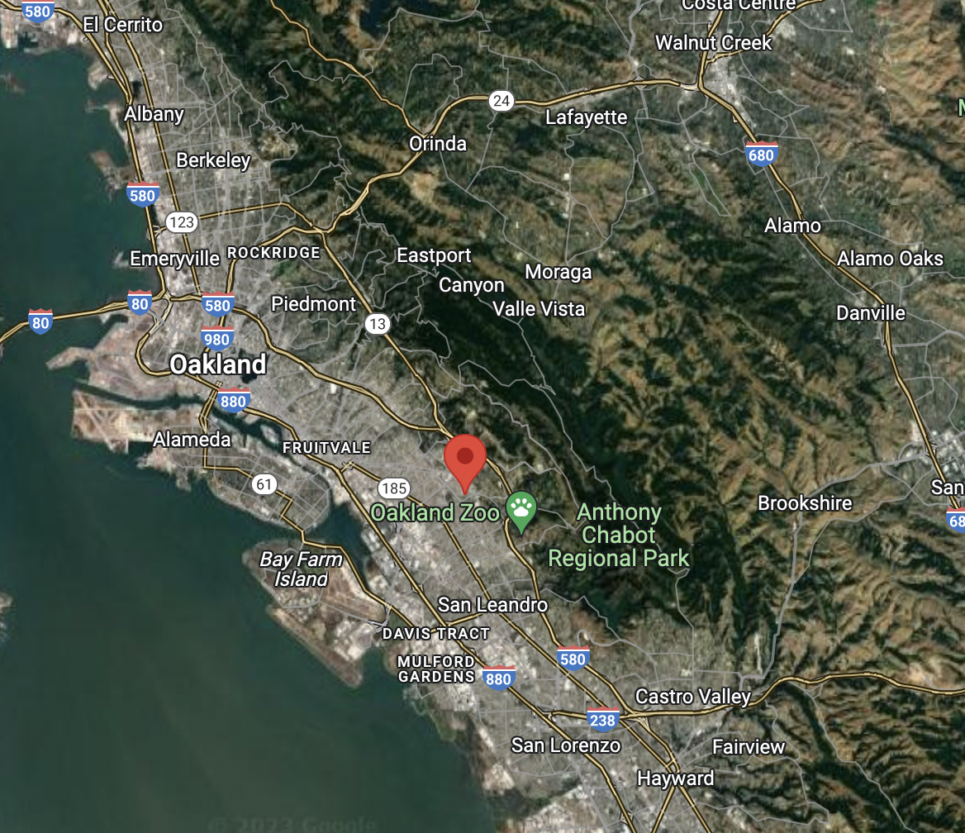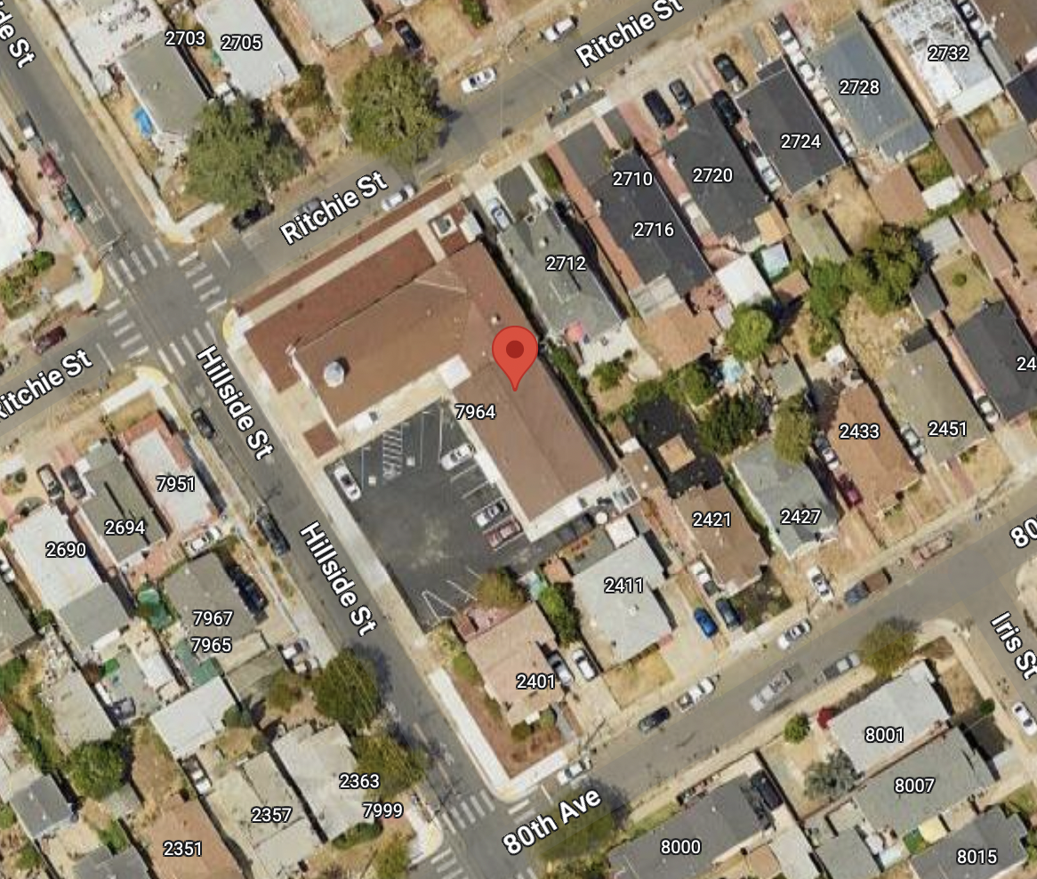
(Google Maps; accessed 25 Sep 2023)

HPC Origins

HPC was founded in 1927 and served an area of East Oakland known as the “Chevrolet Plant field” as at its center was built a Chevrolet automobile plant (1916). In its early years, HPC was primarily a majority white congregation.

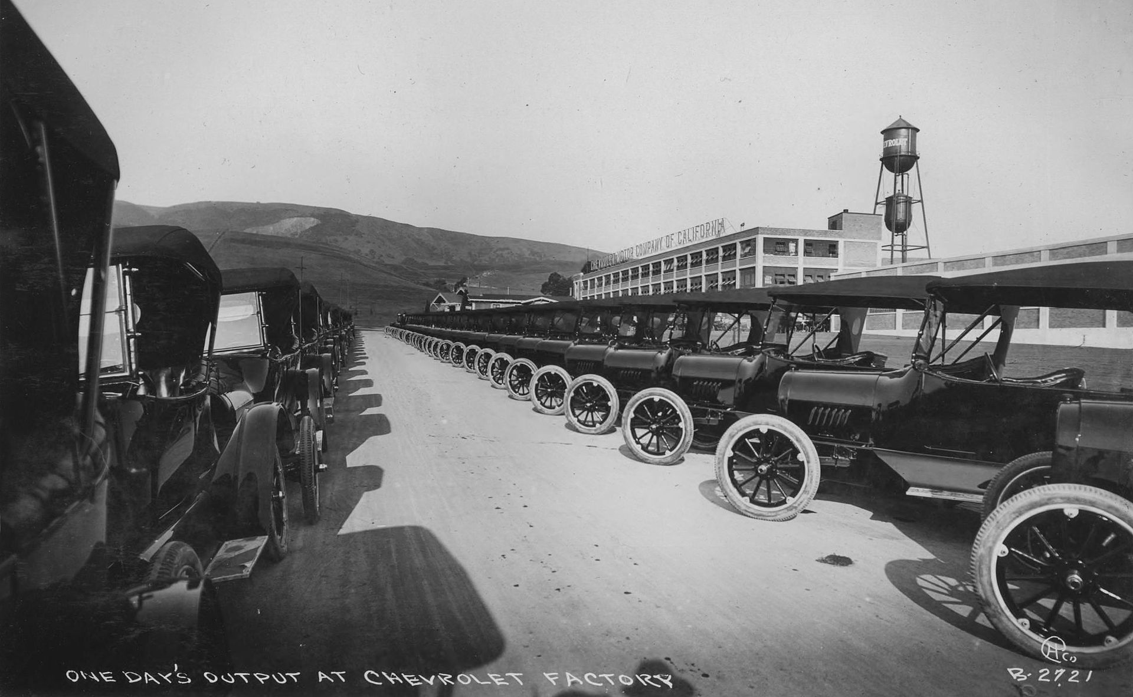
(Chevrolet assembly plant, Oakland, CA circa 1917; source Wikipedia)

Following World War II, the Elmhurst neighborhood of Oakland began to change as larger manufacturing facilities began to close/relocate. The demographics of the neighborhood began to shift from predominantly white to, over time, to predominantly a black population. The congregation of HPC also reflected this change. (Litherland, Rev. R.H.; “Final Report - Interim Pastorate; Hillside Presbyterian Church; January 1992 - September 1992”)

As changes in the neighborhood continued, the size of the HPC congregation became smaller. In turn, financial stability started to become an issue. Litherland noted that HPC was financially stable prior to the changes in the neighborhood over two decades (1960’s - 1980’s), which led to financial concerns for HPC. In the mid-1970’s, Litherland notes that subsidies (in the form of PSF grants along with donations from other local Presbyterian congregations) began to occur on a regular basis. Session minutes from the 1990’s also reflect this condition of financial instability and shrinking congregation size.

HPC/PSF Relationship - 1980’s/1990’s

During the 1980’s and 1990’s, HPC reached out to the PSF with requests for assistance and support during this period of struggle. PSF appeared to be somewhat responsive to HPC (particularly in providing annual grants/subsidies), but it appeared that most PSF responses were in the form of providing what could be possible based upon existing PC(USA) policies and past practices. This included requests for HPC to pursue PSF processes and to provide the necessary information needed outlined by PSF. One example of this was the need for HPC to complete a “mission study” (part of the initial process of approaching the PSF’s Committee on Ministry regarding a pastoral search). It appeared that HPC did not have the person-power resources to complete a full mission study, although the then interim pastor helped HPC complete what they called, “1993 Mission Design for Hillside Presbyterian Church”.

The financial struggles of HPC also contributed to the inability of HPC to be able to hire anything more than short-term, interim pastoral support between 1987 - 2004. (Unknown author; handwritten “History of HPC Pastors 1926-2004). PSF attempted to assist HPC in finding temporary pastoral support (interim pastors, temporary designated pastors, part-time support from seminary students, etc.) but did not look beyond this traditional paradigm rather than examining the Presbytery’s mission in this neighborhood beyond the need of hiring a part-time pastor.

In the documents that T-CARE was able to locate in PSF files and elsewhere, it was noted (in more than one document by different individuals that had been involved with HPC during the 1990’s and early 2000’s) that the PSF “neglected” this congregation, including one comment specifically attributing this to “institutional racism”. (Carrie Buckner conversation with Paul Connor; email June 23, 2004)

The decline of HPC continued and issues of mistrust grew amongst those remaining in the congregation during the late 1990’s into the early 2000’s. The decline appeared to peak in March 2004 when HPC Elder Abner D. Walton sent a letter to the PSF’s Committee On Ministry (COM) recommending the dissolution of HPC. (Walton; “Closure of Hillside Presbyterian Church”; letter to Committee On Ministry; March 2, 2004)

During this period of time, it was also recommended that a study be completed to discern the mission of the Presbyterian Church in this neighborhood of East Oakland.

Closure of HPC/Sale of Church Property

An Administrative Commission was formed to evaluate the situation at HPC along with the HPC Session. The work of the Administrative Commission concluded that the closure of HPC and the sale of the church property were the appropriate actions to be taken.

Pastors from six (6) remaining predominantly black churches in the PSF authored a letter to the PSF recommending that the proceeds from the sale of the HPC property be shared amongst the remaining black congregations in order to “honor the intent to support and foster vital congregational mission for and by African-American churches in our Presbytery.” (Multiple authors, “From majority African American/African Congregations of San Francisco Presbytery”); “Statement on the Legacy and Witness of Hillside Presbyterian Church”; undated).

Research completed by the late Rev. Leonard Nielson in early 2017 indicated that the distribution of the proceeds of the sale of the HPC property to the remaining African American/African congregations was agreed upon but had not been completed despite the sale of the property in 2005. (Nielsen, L.; “Hillside Sale Proceeds - Initial Research”; Jan. 3, 2017). Further research by T-CARE confirmed that the first distribution of these funds did occur, but not until February 22, 2018 (thirteen years after the sale of the HPC property). A second distribution was made on October 17, 2018, while the third and final distribution was made on July 29, 2019. The payments included PSF’s estimated interest that would have accrued between 2005 and 2018. (PSF; “Vendor QuickReports - January 2018 - December 2019”; Accounting records of distributions printed June 30, 2023; PSF; Excel Spreadsheet “Hillside Summary for Investment Committee, May 5, 2008; PSF; “Interest Calculations”; undated)

Again, as part of this property sale process, it was recommended that a task force of some kind be established to examine ministry needs and to strategize for a Presbyterian presence in East Oakland. It is unclear if this work ever was completed or even gained any traction.

Summary/Findings

Based upon available information, T-CARE has identified the practice of institutionalized and systemic racism as part of the PSF’s response to the decline of HPC and also the handling of the sale proceeds from the sale of the HPC property (delayed distribution while utilizing the proceeds for other PSF priorities at the time, including as security for the refinancing of the loan for Westminster House in 2005 and an equity share loan to Interim Executive Craig Palmer in 2007). Also, instead of looking in-depth into how the Presbyterian church could change to meet the needs of the community, it appears the PSF came to the conclusion that the “square peg” of the Presbyterian church just could not fit into the “round opening” representing the needs in the community from this church, therefore HPC was dissolved. (PSF: Excel Spreadsheet “Hillside Summary for Investment Committee, May 5, 2008;)

________________________________________________________________________________________________________________________________________________________

(These are background notes that contributed to the draft narrative above)

Hillside Presbyterian Church (HPC) in East Oakland was closed in the early 2000’s and the property was sold by the Presbytery of San Francisco (PSF). The property, 2708 Ritchie St., Oakland, CA 94605, is currently occupied and owned by Genesis Worship Center (https://genesisworshipcenter.com/).

The closure of HPC was identified as a case study of interest for the Truth Commission Assessing Race and Equity) T-Care’s history task group (examination of specific periods of time, specific events, etc. that can be used to evaluate the PSF and determine how it either responded or not in relation to issues related to race). HPC, at the time, was one of the predominantly African American congregations in the PSF.

The issues that were initially unclear to T-Care members regarding the closure of HPC:

- Disposition/distribution of the proceeds from the sale of the HPC property

  - Six predominantly African American/African immigrant congregations in the PSF proposed that the proceeds from the sale of HPC be distributed evenly between their congregations

    - Elmhurst Presbyterian Church
    - Faith Presbyterian Church
    - Ingleside Presbyterian Church
    - New Bridges Presbyterian Church
    - New Liberation Presbyterian
    - Sojourner Truth Presbyterian Church

  - T-Care requested from information from PSF files related to the closure of HPC

  - Was there documentation of these distributions being made and when?

- Relationship between PSF HPC during their decline, but prior to the decision to close.

  - It is not clear what the relationship between the PSF and HPC was like prior to the church’s closure.

  - What was the nature of this relationship prior to the closure of HPC?
    - What actions or effort, if any, did the PSF take to come alongside, support, encourage, or assist HPC during the church’s decline (well before the decision to close)?

FINDINGS

- PSF Records/Files on HPC Closure

  - After placing the request to the PSF, several of the staff responded that they would search the PSF files for this material.

  - Marda Quon Stothers, Partner of Mission and Church Assets (Transitional Executive Partner) provided T-Care with several electronic documents.

    - The documents included specific information on the sale process of the HPC property.
    - Also included were summary notes compiled by the late Rev. Leonard Nielsen from 2017-2018. (“Hillside Sale Proceeds Initial Research of the Records From Leonard Nielson Jan. 3, 2017”)

      - The notes documented the decision made by PSF to close HPC.
      - Details of the sale of the HPC property.
      - Discussions regarding the distribution/use of the proceeds from this real estate transaction.
        - Letter from the 6 predominantly African American/African immigrant congregations in the PSF (requesting that the proceeds be distributed evenly between these 6 congregations in order to further the ministry of HPC/support African American/African immigrant ministries within the PSF/or in East Oakland.
        - Nielsen’s summary notes of his research of PSF files, meeting minutes, etc. regarding HPC
          - March 2004 - PSF established Administrative Commission (AC) to work with HPC
          - September 2004 -AC submits report at PSF meeting; PSF approves motion:
            - Concurs with recommendation to close HPC.
            - AC to continue to work with HPC
            - Allow AC to convene a meeting of representatives from Healthy Congregations Ctte, HPC Session, and FPOC to determine future use of HPC property for ministry*
            - *“In the Presbytery minutes I found no record of who may have been on that Task Force and if/when it was established, or of a formal proposal for an urban strategy in East Oakland. Pete thought that Greg Chan and Joan Fong might have served on the Task Force, and that any report may have gone to Council. Greg reports that he was not on the TF. Joan has since passed away. There are no official minutes of the Council in the archives.”
            - “Whatever happens I would like to get this to the Feb. 2018 Presbytery meeting for a formal vote.” If the closure of HPC was approved in 2004, why is it that discussions were continuing in 2018?
    - Is there any additional information documenting any existence/work of this “Task Force” (urban ministry/East Oakland)?

  - Email exchange with Rev Kamal Hassan (May 24, 2023) - re: sale proceeds
    - T-Care member Rick Leong emailed Rev. Kamal Hassan, present pastor of Sojourner Truth Presbyterian Church, and asked Rev. Hassan if he knew anything about the distribution of the HPC property sale proceeds. Rev. Hassan responded, 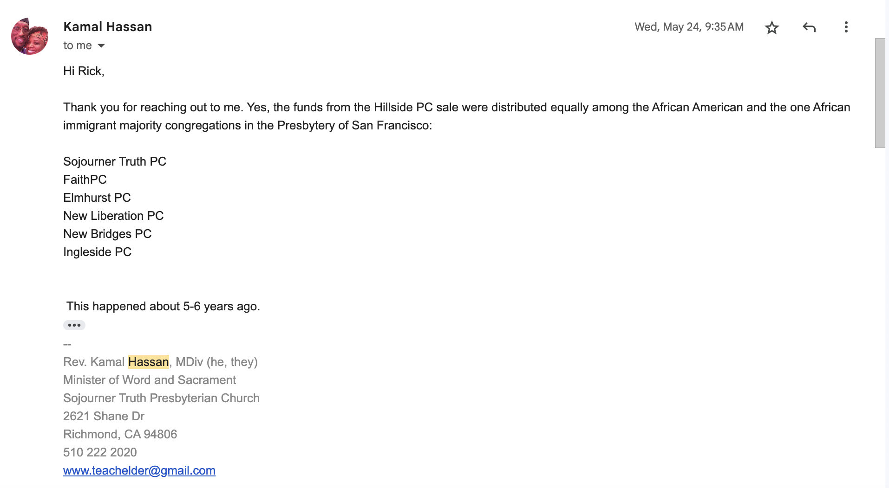
    - June 30, 2023: Received email from Marda Quon Stothers with information and attachments (pdf document/source PSF Treasurer) that document Hillside proceed distributions were made to Ingleside, New Bridges, Faith, Sojourner Truth, Elmhurst, and New Liberation congregations in Feb. 2018.
    - The sale of Hillside property occurred in 2005. What were the reasons that caused approximately 13 years to pass before the processing of the payments to the 6 churches.?
    - Where did the proceeds from the sale of the church property reside in the Presbytery during the decade between the completion of the sale and actual disbursement to the churches? Also - need to review how the interest-earned was calculated in order to confirm that the amounts dispersed to remaining African-American churches was done accurately.

- The Decline of HPC

From Report of Hillside Administrative Commission; 3080; Sept. 14, 2004 - Presbytery of San Francisco; Moraga Valley Presbyterian Church; Appendix 7, Page 1

  - “Prior to the March 4th meeting, COM had received a four-page letter from Elder Abner Walton, a current session member at Hillside, indicating ‘a session that is totally dysfunctional and cannot provide effective leadership to the congregation as well as the community.’ Elder Walton closed his letter by stating, ‘I strongly recommend the dissolution of Hillside Presbyterian Church.’”

    - Is there a copy of Elder Walton’s letter in PSF files?

      - Copy of letter from Elder Abner D. Walton to Committee on Ministry (COM - PSF); dated March 2, 2004; located in “Hillside” files stored at the former Fruitvale Pres Church (Follow-up research; Aug 15, 2023)

        - “It is my sincere belief with the present membership in place, Hillside needs a drastic change in order to survive, and I don’t see that in the near future. I strongly recommend dissolution of Hillside Presbyterian Church.”

  - “The Administrative Commission decided to contact several African-American leaders within the Presbytery to seek their insights and consultation.”

    - Are there records of these insights and consultation with these leaders within PSF records?
      - Email correspondence was discovered during follow-up research (Aug 15, 2023)

        - Joan Huff to Administrative Commission (email, June 17, 2004); RE: Joan Huff conversation with Carmen Mason-Browne; “She felt that the presbytery did not respond to the needs of the church at that time [when Mason-Browne served as part-time solo pastor at Hillside] or since then.”

        - Ron Thompson to Administrative Commission (email, June 22, 2004); RE: Ron Thompson conversation with James Noel; “Sell property and hold funds until a new ministry under new leadership can begin in a viable neighborhood. (Did not someone tell us that close-by are young Af/Am families with children?)”

        - Carrie Buckner to Administrative Commission (email, June 23, 2004); RE: Carrie Buckner conversation with Paul Connor; “He did raise two key themes I think we should address. First, what he called institutional racism in the Presbytery about neglecting the issues/concerns at Hillside for so long. He also mentioned that it is not good to place new seminary grads (all African-American) at Hillside and the ‘string’ of dynamic pastors who have been burned out by their experiences there.”

        - Josie Abrams to Administrative Commission (email, June 21, 2004); RE: Josie Abrams conversation with Roland Gordon; “He was unaware it was this close to closure. He felt Hillside and Elmhurst should have merged a long time ago.”

  - “July 11, 2004: The Administrative Commission met with the HPC session to discuss the health and the mission of the church.”

    - Ron Thompson to Administrative Commission (email, July 11, 2004); RE: Adm Comm, meeting with Hillside Session: “We apologized for Presbytery not giving the kind of help and support for pastors and Hillside. We told of calling African-American pastors asking them for their insights.”; “We encouraged them to consider other Presbyterian churches in the areas and that down the road Presbytery would continue to be active in the area.”

  - “July 21, 2004: The Administrative Commission met to hear reports on conversations with African-American who were contacted. It was clear from the reports that the Presbytery should have intervened years ago. The term “benign neglect” was used repeatedly by persons when referring to the Presbytery’s handling of Hillside.”

  - Meeting minutes; Administrative Commission; July 21, 2004. “Ron asked what we learned from our conversations about Hillside with key African-American leaders in the Presbytery. Overall, the people we talked to with who have a long history in the Presbytery support closing the church. Ron commented on how ‘alone’ pastors who have served at Hillside have felt. This has been a learning for him regarding solo pastors in our urban churches.” “ Dave [Hawbecker] reported on his conversation with Frank Jackson. Frank shared that he hoped there would be a new initiative in East Oakland - an active, healthy, positive Presbyterian presence. As the convenor of the African-American pastors group in East Oakland, Frank felt that the group would support a new vision/ministry opportunity in East Oakland.”

  - “August 17, 2004: Upon hearing a report from Elder Abrams-Lawrence, Elder Sweis and Rev. Thompson, the Administrative Commission listed their finds from the various meetings they had with members of Hillside Church:

The following list was compiled:

No Christian education program;
Lack of accountability on finances;
No common/shared vision;
No officer training;
Property not maintained;
Lack of record keeping;
Session does not provide spiritual leadership;
No Bible study;
No mission outreach;
No youth presence;
Limited pastoral care;
Lack of fellowship/care;
Poor administration”

    - For what period of time were these conditions present?
      - Congregational Meeting Minutes Based upon available HPC Session meeting minutes (earliest available from 1992), the decline of HPC goes back as far as the early 1990’s.
      - Additional documents/correspondence between Synod of the Pacific/Presbytery of San Francisco and HPC documents the pastoral vacancy issue as early as 1978.
        - Synod/Presbytery recommendation to HPC in the 70’s and 80’s was to pursue interim/designated/stated supply pastoral services while a process for developing “the study on the future if Presbyterian witness and ministry in the East Oakland area”. (Memorandum dated Sept 22, 1987; Bert Tom to Woody Bussee and Mose Thornton)
        - Reference to a “strategy” for East Oakland is mentioned in 1979, 1987, and in 2004.

- Relationship Between PSF and HPC During HOPC’s Decline

  - What, if any, did the PSF do to come alongside this congregation during this period of decline?
    - An undated document titled, “Hillside Notes” appears to a summary from the Rev. Wanda Shannon, stated supply (based upon the contents of the document). “I hope you will allow me to express my personal concerns. The presbytery has failed this congregation by allowing them to continue so long in a state of inertia. The session has become a group of people in whom bad habits have become the norm. For years too long to count the church has been falling apart from any formal governance, drifting away into no known structure. I have tried to create an atmosphere where the members on the periphery would feel safe to return. I called everyone even Elizabeth Walton and promised to help correct the situation of rule by the power and control seekers. There are those who will never return until they see some form of concern set forth by the presbytery. With a constant turnover of pastors, with the extended use of temporary supply and the lack of strong administrators how can the presbytery expect this church to survive.” “I am asking you to help. Even if this church closes the few who love the Lord deserve to leave with dignity, knowing that all was done within reason by the presbytery to help.”
  - Consideration of Partnership between HPC and Elmhurst Presbyterian Church
    - Memo dated 9 July 1998; To: Matt Croughan and Janet Russell, From Bert Tom (attachment: “Draft of Plan for Hillside Presbyterian Church, Oakland; June 28, 1998”)
    - What actions, if any, did the Presbytery take in response to
      - Partnership between HPC and Elmhurst
      - Need for Mission Study for HPC
  - “Temporary” pastoral leadership
    - “Ms. Vanessa Johnson, Parish Assistant (1994-1998); Rev. Dr. Ophelia Manney, Temporary Stated Supply (1997); Rev. Dr. Richard Litherland, Temporary Stated Supply (1998-1999); Rev. Dr. Reginald Nichols, Stated Supply (2000-2001); Rev. Charles Tinsley, Temporary Supply (2001-2002); Rev. Wanda Shannon, (9/2003 - 2/2004); Rev. Charles Tinsley, Pulpit Supply (2/2004 - 10/2004) (from undated handwritten pastoral history list for period 1994-2004)
    - “Future Staffing Possibilities: For over a dozen years Hillside Church has had only comparatively short term (maximum 3 years) pastoral leadership, subsidized by the Presbytery.” (from letter to Healthy Congregations Committee of PSF from Rev. Litherland dated October 11, 1999) + attached “Brief Summary 1998 - October 1999 Hillside Presbyterian Church Oakland California”)
    - “Even with subsidies from the Presbytery and from sister churches, the church (HPC) has only been able to pay only for part-time ordained leadership. (Since about 1980)”. (from Sept 29, 1993 “Final Report - Interim Pastorate” by Rev. Dr. Richard Litherland)
  - “Future of Presbyterian Witness and Ministry in the East Oakland Area”
    - Reference to a “strategy” for East Oakland is mentioned in 1983, 1987 and later in 2004.
      - “The REM Committee [Racial Ethnic Ministries Committee] was concerned that the long period of time it takes to call a pastor may delay the plans of the REM Committee to review, in depth, the mission of the Presbyterian Church (USA) activities in the East Oakland area. The REM Committee believes that it is conceivable that a totally new mission strategy for Presbyterian witness in the East Oakland area may emerge from the review.” (Memorandum dated Sept 29, 1983; Bert Tom to Rev. Bob Bennett and Rev. Bill Nebo)
      - Synod/Presbytery recommendation to HPC in the 70’s and 80’s was to pursue interim/designated/stated supply pastoral services while a process for developing “the study on the future if Presbyterian witness and ministry in the East Oakland area”. “This task begins sometime in October and is scheduled to be completed by June 30, 1988 or soon thereafter.” (Memorandum dated Sept 22, 1987; Bert Tom to Woody Bussee and Mose Thornton)

      - Potential resources yet to be located: (referenced in Sept 29, 1993 “Final Report - Interim Pastorate” by Rev. Dr. Richard Litherland)
        - “Informational Paper”; East Oakland Ministry Task Force, Presbytery of San Francisco; 1987
        - “The Council of Oakland Presbyterian Churches: A model for the urban ministry of the Presbyterian Church in the 1980’s”; Tyler L. Breese

- Potential Interviews
  - Rev. Dave Hawbecker
  - Rev. Wanda Shannon
  - Rev. Joel Mackey

Linda's Hillside Accounting Notes.docx

Appendix 6b. Case Study: Primera Iglesia Presbiteriana Hispana & High Street Presbyterian

T-CARE (Truth Commission Assessing Race and Equity) - September 2023
Rick Leong

Preamble: This case study is based on the research completed by one member of T-CARE (Rick Leong). It was based on the written record; not on extensive interviews or focus groups. It should not be taken as a comprehensive report of the issue but as a beginning of a conversation process. These events created, exacerbated, and stirred up deep emotion, much of which is still felt and carried by the people who participated or witnessed them. Our presbytery still needs to reckon with these events. We recommend the Reparations and Community Healing Commission engage with these events by holding a Truth and Reconciliation Process.

In several documents, the conflicts, over several decades, between High Street Presbyterian Church (HSPC) and Primera Inglesia Presbiteriana Hispana (PIPH) have been focused upon their joint use of the property at 1941 High Street in Oakland, California (some documents dating the relationship between PIPH and HSPC as far back as 1999 (PIPH; “PIPH - Our Petition to the Presbytery; undated)

Property - History

“The church lot at High and Courtland was obtained in January 1907, for a total cost of $1200; and in the following March a large tent was pitched on the corner and services were held there.” “Ground was broken for the first building on December 18, 1907... until the new building was completed and occupied on April 5, 1908.” “... on November 18, 1921, the cornerstone of the second building was laid and the dedication service was held the following April.” “The time arrived when still further expansion was necessary. The whole membership combined efforts and a third building was brought to reality (in 1949).” (High Street Presbyterian Church; “News From On High”, The newsletter of High St. Presbyterian Church; April 2001)

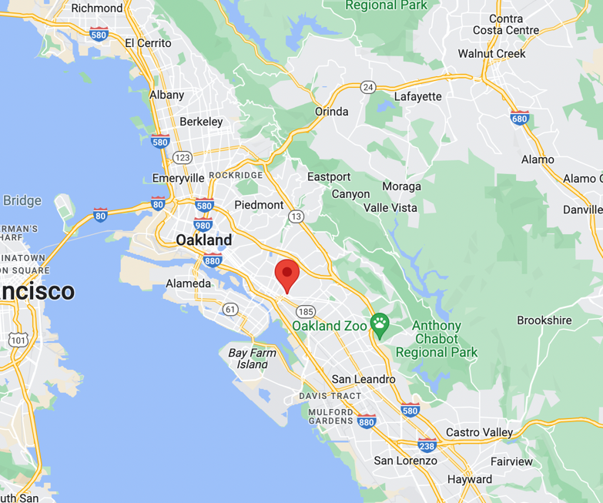
(Google Maps; Accessed 23 Oct 2023)

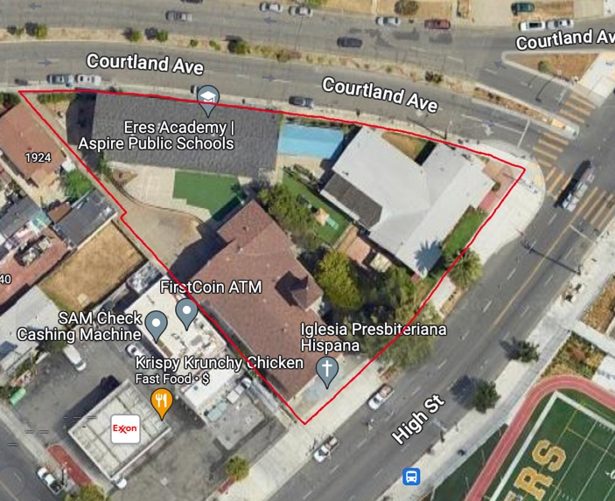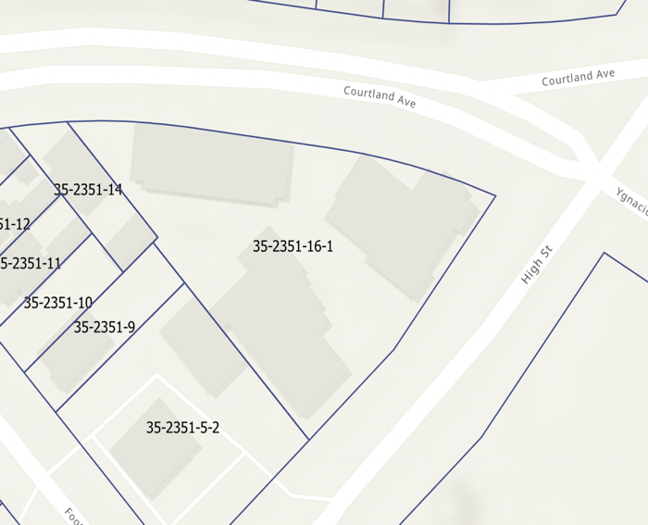
(Google Maps; Accessed 23 Oct 2023). (Alameda County Parcel Viewer; #35-2352-16-1)

HSPC/PIPH Relationship

PIPH was a church plant to minister to the Hispanic community in East Oakland. The PSF originally referred to PIPH as “the Hispanic New Church Development Project” (1991). A report from the “High Street Presbyterian Commission” stated that the PSF voted to dissolve HSPC and to have it replaced by a “Hispanic new church development.” This resulted in a lawsuit being submitted to the Synod of the Pacific (Plaintiff: HSPC; Respondent: PSF). Following this, a compromise was made to “help both ministries flourish using the High Street facility”. (High Street Administrative Commission; “Final Report to S.F. Presbytery from High Street Presbyterian Commission, Oakland”; 5 May 1991).

It is unclear if PIPH and HSPC actually had entered a mutual agreement to share the use of the High Street facility/property, as several documents produced by the 2014 Administrative Commission stated that no use agreement was found or presented. In T-Care's review of the available files, a fully-executed lease/facility use agreement made between PSF and PIPH was found. It should be noted that HSPC was not a signatory to this agreement. (PSF; “Lease and Facility Use Agreement”; Executed on 1 Sep 1991 between PSF, HSPC and PIPH).

Rental Use of Property

The church property and facilities were also rented to two local public education organizations: Aspire Public Schools for their program use for different periods of time (HSPC; “Use Agreement”; Executed 1 Jun 2014 by HSPC and Aspire Public School)

Primary Issues

The issues between HSPC and PIPH spanned decades (90’s, 00’s, 10’s).

- Property Ownership: There was clearly a mixed understanding of “ownership” of the property/facilities at 1941 High Street by each of the Presbyterian parties involved (PSF, HSPC, and PIPH)

  - PSF – Presbytery’s understanding based upon constitutional trust law. The PC(USA) Book of Order: “G-4.0203 Church Property Held in Trust All property held by or for a congregation, a presbytery, a synod, the General Assembly, or the Presbyterian Church (U.S.A.), whether legal title is lodged in a corporation, a trustee or trustees, or an unincorporated association, and whether the property is used in programs of a congregation or of a higher council or retained for the production of income, is held in trust nevertheless for the use and benefit of the Presbyterian Church (U.S.A.).”

  - HSPC – Congregation believed that it “owned” and held 100% control over the property and its use.

  - PIPH – "PIPH always knew that this property was part of the denomination and that there were two churches sharing the space, until through other people, we began to hear that the HSPC were rightful owners.” (PIPH; “Preguntas Para Comision Administrativa Del Presbiterio – AC”; undated)

- Property and Facility Maintenance – dispute over responsibilities for maintenance of facility and associated costs to perform this maintenance.

- Authority to Enter Into and Administer Rental/Use Agreement for a Third-Party - HSPC entered into use agreements with two different educational organizations during two separate time periods (Neither PSF nor PIPH were a party to this agreement). HSPC received the money from these leases.

  - 2008-2009 Dolores Huerta Learning Academy (PSF, Presbytery Meeting Minutes, Nov. 2008, Walnut Creek Presbyterian Church)

  - 2014-2019 Aspire Public Schools (HSPC; “Use Agreement”; Executed 1 Jun 2014 by HSPC and Aspire Public School)

Findings

- In 2014, the Presbytery of San Francisco (PSF) created an administrative commission (AC) “to aid in listening and reconciliation between the neighboring congregations of High Street Presbyterian Church in Oakland and Primera Iglesia Hispana Presbiteriana in Oakland and the Presbytery of San Francisco.” (Administrative Commission for HSPC and PIPH - “Second and Final Report to the PSF; Sept 8, 2015).

- June 3, 2014- Presbytery of San Francisco First Presbyterian Church, Berkeley
Joint Report of the Committee on Ministry (COM} and Finance & Property Oversight Committee (FPOC) -
Meeting Packet: June 3 2014
  - Items for Discussion and Action: 1. MOTION: COM and FPOC jointly recommend that the Presbytery of San Francisco name a special commission of no less than seven people whose task would be to explore the history of all that has been said and all that has been done with High Street Presbyterian Church (HSPC) and Primera Iglesia Presbiteriana Hispana (PIPH), and then recommend a mutually agreed-upon process that seeks to celebrate, nurture and serve the needs of both congregations, neither at the expense of the other. The members of this special commission would be appointed by the Moderator and Vice Moderator, after consultation with the Presbytery Pastor and committee chairs, and would include an equal number of representatives and advocates for both congregations, and at least two representatives from both COM and FPOC.

- Minutes; September 9, 2014 – Presbytery of San Francisco First Presbyterian Church, Oakland

The Stated Clerk informed the Presbytery of the following appointments made to date for the commission, approved by Presbytery at the June meeting, which will work with High Street Presbyterian Church and Primera Iglesia Presbiteriana Hispana in Oakland: Rev. Don Ashburn, Piedmont Community Church; Rev. Keith Geckeler, Honorably Retired; Rev. Kamal Hassan, Sojourner Truth PC, Richmond; Rev. Vanessa Hawkins, Member at Large; Rev. Jeannie Kim, Member at Large; Rev. Max Lynn, St. John’s PC, Berkeley; Ruling Elder Mary Jane Gordon, Ingleside PC, San Francisco; Ruling Elder Tony Montalvo, Primera Iglesia Presbiteriana Hispana, Oakland; Ruling Elder Ana Hernandez, Primera Iglesia Presbiteriana Hispana, Oakland. Additional appointments will be made to complete the commission, including at least two ruling elders from High Street Presbyterian Church. This fall, once the appropriate composition has been met, the commission will begin its work to listen to the histories of the two congregations and to explore ways to ease tensions between the two so that both congregations may thrive, neither at the expense of the other.

5186 November 10, 2015 – Presbytery of San Francisco First Presbyterian Church, Oakland Appendix 11, Page 1

- Administrative Commission for High Street and Primera Iglesia Second and Final Report to the Presbytery of San Francisco Meeting on November 10, 2015 at First Presbyterian Church of Oakland

Motion 1: “the Presbytery of San Francisco VOTED to confess its failures in process and procedures since 1987, thus creating and maintaining misunderstandings and mistrust in the relationships between the Presbytery, Primera Iglesia Presbiteriana Hispana, and High Street Presbyterian Church.

Motion 2: “the Presbytery of San Francisco VOTED to acknowledge the right of High Street Presbyterian Church to oversee the Constitutional use of its facilities. The Presbytery may exercise authority properly provided for in the Constitution (e.g. the use of "real property used for “worship” or the implementation of “original jurisdiction” if the session is “unable or unwilling” to resolve difficulties. (G-3.0303e).

Motion 3: “the Presbytery of San Francisco VOTED that the Presbytery of San Francisco suspend the portion of the Standing Rule 6.3.1, which requires a minimum of seven persons on a commission to allow for a smaller commission to be appointed in action #4 to follow.”

Motion 4: “the Presbytery of San Francisco VOTED that the Presbytery appoint at today's meeting a commission of at least three people with the authority to act as Presbytery in carrying out the functions of G-3.0301 and G-3.0303: (especially " ...guide, encourage, support, and resource the work of congregations for the most effective witness to the broader community." And "...providing encouragement, guidance, and resources to congregations in the areas of mission, prophetic witness, leadership development...evangelism and responsible administration...".)
a. Engage in conversations with High Street Presbyterian Church regarding the possibility for resolving the existing situation by entertaining one of several options for guaranteeing both congregations long term use of their facilities;
b. If “a” proves successful, to enter into negotiations with High Street and Primera Iglesia to produce a Covenant and Contract acceptable to both congregations; [This assumes the probable need for legal advice and professional services (including translation) to accomplish these documents];
i. That guarantees both congregations the freedom to conduct their worship and ministry without undue interference or fear of loss of their congregational space;
ii. That insures both congregations will be able to function for the next decade or two without fear of catastrophic maintenance or repair costs beyond the resources of either congregation;
iii. That will involve consultations with the Committee on Ministry and the Finance and Property Oversight Committee.
c. To facilitate the work of this commission, the presbytery guarantees up to $1,500,000 to accomplish “b”, including property improvements, professional costs, and lease or purchase costs – as well as initial support for mission and ministry until resolution of the school lease and determination of any long term mission support from presbytery.
d. If “a” or “b” proves unsuccessful, this administrative commission will be a commission to advocate for Primera Iglesia in locating:
i. Facilities for short term (up to two years) use which are acceptable to the congregation and presbytery.
ii. A permanent “home” for the ministry and mission of Primera Iglesia.
iii. Financial support to make “d.i” and “d.ii” possible (including possible need for purchase of property) – as well as to support that mission which reflects the goals and mission of the presbytery.
e. To serve as a mediator alongside the congregation in negotiations for Items “d.i” and “d.ii” and “d.iii” (G-3.0303d(2)).”

Motion 5: the Presbytery of San Francisco VOTED that the Finance and Property Oversight Committee and the Committee on Ministry appoint a project team of at least 7 people to develop a comprehensive strategy for the support and development of other new congregations struggling with similar nesting issues as exist in this situation.

Motion 6: “the Presbytery of San Francisco VOTED that COM be encouraged to use the authority of G-3.0303 to address issues related to the relationship between the two pastors as well as issues related to pastoral behavior and leadership of both congregations.”

Summary of Learnings

“We came to understand that the presbytery played an active role in creating the climate of mistrust and misunderstanding which exists between High Street Presbyterian Church, Primera Iglesia Presbiteriana Hispana, and the Presbytery of San Francisco.”

“We affirm High Street’s ongoing stated commitment for Primera Iglesia to have a home in their building for worship and ministry but have come to question whether this is still true.”

“We are unclear as to the exact nature of the formal relationship between the two churches. There is no recent (within 10 years) “covenant agreement” anyone can provide.”

“Because of the way in which presbytery sought to create Primera Iglesia, there has been a constant and continuous series of misunderstandings related to the High Street Presbyterian Church property.”

“We believe that unequal power dynamics between Primera Iglesia, High Street, and the presbytery and a lack of effective tools for multicultural communication and understanding have played a role in the conflict between the three parties.”

“It is our conclusion that after 25 years of off and on discord, it is unlikely (in the foreseeable future) for these two congregations will find a mutually agreeable long-term relationship with regard to the property.”

“It is our conclusion that the inability of the two pastors to work together productively without third parties present is one reason for the present impasse.”

“It is our conclusion that the presbytery, going forward, must acknowledge the ongoing sense of loss of “home” by Primera Iglesia members as well as the grief and feelings of injustice should it need to relocate—and that presbytery must take affirmative action to ameliorate these realities.”

Conclusions/Recommendations

“Following meetings with both congregations, both sessions, and both pastors, this Commission reports they have been unable to find—and they do not anticipate finding--a mutually agreed upon process of reconciliation that might resolve the mistrust, anger, hostility, lack of communication, and feelings of disrespect harbored by both congregations toward each other and the presbytery. We thus confess our inability to fully meet the commission given to us.”

5267 August 27, 2016- Presbytery of San Francisco Christ Presbyterian Church, San Leandro Appendix 3, Page 1

The original report was produced in both English and Spanish. This version for the minutes is English only. REPORT OF THE ADMINISTRATIVE COMMISSION WORKING WITH HIGH STREET AND PRIMERA IGLESIA PRESBYTERIAN CHURCHES Presbytery of San Francisco August 27, 2016 Agreement between The Presbytery of San Francisco, High Street Presbyterian Church and Primera Iglesia Hispana. (06-23-16)

1. The Presbytery will spend up $500,000 to address repair and maintenance needs of all three buildings on the property shared by the churches.
2. This work will be managed by the Presbytery and provided at no cost to either church with the understanding that High Street will release all past and future claims of rent or payment from PIPH except as provided herein.
3. Pursuant to provisions of the Book of Order enumerated in G-4.02 and subject to conditions set forth herein, Presbytery will assign control and ability to collect rent from and responsibility for on-going maintenance and payment of insurance, utilities and property tax assessments as to the three buildings as follows: a. Complete use and responsibility for the Julia Morgan building and the education building to HSPC. b. Complete use and responsibility for the sanctuary building at 1941 High Street to PIPH. c. So long as the current Aspire Charter School lease is in effect, the terms of that lease will remain unchanged. When the existing lease with Aspire Charter School is terminated Presbytery will have the right of first refusal to lease the education building for use by PIPH in its ministries. d. Should the lease be renewed, PIPH will have the right to collect rent money for use of the downstairs social hall and kitchen in the building at 1941 High Street.
4. Presbytery will continue its present financial support for the work of PIPH and in addition will allocate up to $7,500 per month for the next ten years (and renegotiable thereafter) to rent classroom space (including space in the education building as mentioned above) in the vicinity of the church.
5. In the interest of maintaining a good working relationship between the congregations Presbytery will designate a person acceptable to both churches to be always available to assist in the mediation and resolution of any issues that may arise between the congregations.

5315 May 9, 2017 – Presbytery of San Francisco Trinity Presbyterian Church, San Carlos
- Report of the Administration Commission for High Street Presbyterian Church - Rev. Kathy Runyeon reporting Kathy introduced members of the commission and shared a summary of the packet report. (See Appendices 4 and 5.) She invited questions of clarity. Fred Harvey, member of the AC, added a prayer of appreciation for HSPC who just celebrated 110 years of service as a congregation in the High Street neighborhood.

1. MOTION: The Administrative Commission for High Street Presbyterian Church, acting as the Session and trustees of the High Street Presbyterian Church following the resignation of the congregation, recommends that the Presbytery of San Francisco dissolve the Congregation of High Street Presbyterian Church according to the following terms: The Congregation of HSPC would be dissolved on July 1, 2017, provided that the requirement (of Motion #2) to transfer the property trusteeship to Primera Iglesia Presbyteriana Hispana, Oakland, and to retitle the real property into the name of the Presbytery of San Francisco has been completed by that date. If either of these two conditions is not completed as of July 1, 2017, the formal date of dissolution will be the date on which both of these requirements have been completed.

2. MOTION: The AC for HSPC, acting as the Session and trustees of the High Street Presbyterian Church following the resignation of the congregation, recommends that the Presbytery of San Francisco transfer the real and personal property of High Street Presbyterian Church to Primera Iglesia Presbiteriana Hispana, Oakland, according the following terms: (For terms, see REPORT #9 – COMMISSIONS.)

Committee On Ministry

1. MOTION: The Administrative Commission for High Street Presbyterian Church, acting as the Session and trustees of the High Street Presbyterian Church following the resignation of the congregation, recommends that the Presbytery of San Francisco dissolve the Congregation of High Street Presbyterian Church according to the following terms: The Congregation of HSPC would be dissolved on July 1, 2017, provided that the requirement (of Motion #2) to transfer the property trusteeship to Primera Iglesia Presbyteriana Hispana, Oakland, and to retitle the real property into the name of the Presbytery of San Francisco has been completed by that date. If either of these two conditions is not completed as of July 1, 2017, the formal date of dissolution will be the date on which both of these requirements have been completed.

2. MOTION: The AC for HSPC, acting as the Session and trustees of the High Street Presbyterian Church following the resignation of the congregation, recommends that the Presbytery of San Francisco transfer the real and personal property of High Street Presbyterian Church to Primera Iglesia Presbiteriana Hispana, Oakland, according the following terms: (For terms, see REPORT #9 – COMMISSIONS.)

- 5327 May 9, 2017 – Presbytery of San Francisco Trinity Presbyterian Church, San Carlos Appendix 4, Page 1 REPORT FROM THE ADMINISTRATIVE COMMISSION FOR HIGH STREET PRESBYTERIAN CHURCH Presbytery of San Fra cisco May 9, 2017

- An addendum to the report of the PIPH/HSPC Commission of the Presbytery of San Francisco. For Presbytery of San Francisco meeting on May 9, 2017

Commission Report

“At its meeting on November 15, 2016 the Presbytery of San Francisco took the action shown below and established this commission. As reported then, the Rev. Linda Gruel, then pastor at High Street, renounced the jurisdiction of the PC(USA) while under accusation for disciplinary offenses. The session had resigned en masse and sent the Presbytery notice of their intent to dissolve the congregation.”

“At their meeting in October, 2016, the session authorized disbursements to mission organizations and to members and staff, virtually depleting their treasury. The commission was grateful for the decisions to distribute $5400 in support of local mission groups but believes the other disbursements, totaling $40,234.56, as contrary to the PC(USA) trust clause that says assets are for the good of the whole church. Note that Anore Shaw was not present for the October 2016 session meeting, but otherwise many checks were authorized by the persons present as disbursements to themselves. Most checks were signed by Janet Kirk; exceptions are the check to Janet which was signed by Nancy Gruel and the check to Vivian Louie which was signed by both Janet and Nancy. Noted for the record, but not for action, below is a list of the disbursements that the AC feels are questionable. Presented as 3 months of “normal monthly stipend” to staff members, these checks could be justified as severance but are not accurately noted as compensation: Cynthia Rose $750 Alejandria Sales $600 Linda Gruel Neff $6,634.56 These checks were listed as “in kind gifts” for “dedicated membership.” Items marked by an asterisk were authorized by the session elders and given to themselves. Anore Shaw $1,750 Edna Barner $1,750 Barbara Forsberg – for Bob Forsberg $1,750 Sal Zargoza * $1,750 Archie Ingram * and Kathy O'Toole $1,000 Janet Kirk * $7,500 Nancy Gruel * $7,500 Vivian Louie * $7,500 Marian ‘Edie’ Eddens * $1,750”

“All commission members were present except InHo Kim who was ill. The AC reviewed all previous items of business. By consensus the commission agreed that membership is now zero.”

“The commission recognizes these disbursements as irregular, and possibly illegal, actions but has chosen but to pursue litigation at this time. Consensus is that the commission does not want to pursue legal action now, but will include the information in a report to presbytery and send that report to those members.”

An addendum to the report of the PIPH/HSPC Commission of the Presbytery of San Francisco. For Presbytery of San Francisco meeting on May 9, 2017

During the summer of 2016 the Commission tasked by the Presbytery of San Francisco to find a permanent home for the life and ministry of Primera Iglesia Presbyteriana Hispana issued a report outlining our conclusion that the very best— indeed the only realistic—home for Primera Iglesia Presbyteriana Hispana was the one they had been using for decades. In order to make our conclusions work, however, we had to address the concerns of High Street Presbyterian Church which was, in effect, PIPH’s landlord. Not long after receiving our report, the entire congregation of High Street Presbyterian Church resigned its membership in the church. In light of this development, the Commission proposes that the High Street Presbyterian Church property be transferred to the Presbytery of San Francisco, with the understanding that the Presbytery will designate the property in its entirely to PIPH. In order for this transaction to transpire, we recommend the following actions: • Upon dissolution of High Street Presbyterian Church as a congregation, and consistent with G-4.0203 of the Book of Order, PIPH would become primary trustee of and responsible for all of the real and personal property of HSPC, for the use of and under the trustee control of PIPH, as if they had originally purchased the property. Legal title will be vested as “The Presbytery of San Francisco.” • For the remainder of the term of the current lease with Aspire Schools, “Landlord” control will be transferred to both PIPH and Presbytery. As of the date of the transfer of the lease and the property, all lease income would go to PIPH and all current and future expenses for the property, including maintenance, taxes, and capital costs would be assumed by PIPH. The unused space of HSPC that is not currently rented to Aspire would be under the control of PIPH, including any additional rent if PIPH chooses to rent it out. When the lease expires, PIPH will be free to choose a new tenant or to renegotiate a new lease with Aspire. PSF would remain as a co-signer of the lease under any Book of Order provisions and under any State Law requirements. • The current financial support that Presbytery sends to PIPH, which is $6000 per month, would end as of the date of the transfer of rental income to PIPH. • The Presbytery of San Francisco will assume the costs of repairs to the property that have already been completed or that are underway. (To date Presbytery has spent approximately $140k on the roof and the drainage at PIPH, and has a commitment to do lead abatement in the amount of approximately $35k, as well as a commitment for some roof repairs to the Julia Morgan roof in the amount of approximately $4.5k; these expenses will not be transferred to PIPH but will be assumed by PSF.) REPORT #9 COMMISSIONS 3 - 2 • Over the next 5-10 years, there will be additional improvements needed throughout the property for roofs, drainage, landscaping, walkways, tree removal, electrical upgrades, sewer replacement, painting, roofing and gutters, furnace replacement, bathroom replacements, kitchen upgrades, flooring and painting, and possible classroom upgrades. These costs are expected to be in the neighborhood of $250k - $400k. To ensure that PIPH has a reliable funding source for capital improvements, PSF would establish an interest-only Line of Credit (LOC) to PIPH. The terms for the LOC would be the same basic terms of the an emergency loans made to several of our churches: 4.5% yearly interest on any balance, paid monthly, except that it would be a 10 year term. At the end of the 10-year period PSF and PIPH will renegotiate the loan. For any work done using the LOC, Presbytery would work with the congregation to ensure that all liens are expunged, bills paid and contracts well written on behalf of the church. PIPH will request assistance from PSF as needed for facilities evaluation, training for building maintenance (large and small projects), and for the timing and planning of when capital work should be undertaken. We propose that the above actions happen concurrently with the formal and legal dissolution of High Street Presbyterian Church.

T-CARE Findings

- The Presbytery of San Francisco admitted that they contributed to the difficult relationship between High Street Presbyterian Church & Primera Inglesia.

- The PSF CHOSE NOT to pursue any form of judicial process in addressing the then HS pastor’s potential missteps and the highly questionable distributions to HSPC pastor, staff, and remaining congregants before they “self-dissolved”. This gives the appearance that the PSF decided not to pursue reparations from a legacy white congregation for funds (~ $40K) that would have been very helpful to Primera Iglesia.

Additional Information from December 4,2024 Conversation Circle from Rev. Pablo Morataya
Before the COM approved the arrival of Rev. Linda Gruel as HSPC pastor, the PIPH consistory requested a meeting with the committee. At the meeting, the PIPH consistory requested that the decision be seriously considered. The main reason was because the history between Rev. Gruel and PIPH had been negative.

PIPH supported her going to seminary as well as coming under the care of CPM. As she progressed in her studies, she began to change. She defamed the pastor, the leadership and manipulated a couple of family members who ended up leaving the church along with her.
COM did not take into account the request of the PIPH session, approved that she become pastor of HSPC and the problems were not long in coming. Led by the pastor, they took control of the buildings, put pressure on PIPH to leave the buildings and ultimately ended up dissolving the HSPC church and she relinquished jurisdiction as minister of the PCUSA. In an ideal world, COM should have apologized to the PIPH council for its mistaken action but did not.

The aftermath of bad experiences is still in force in some individuals and families. There was never a healing process. For future experiences like these, it is important to keep in mind that wounds do not heal on their own.

Additional notes/references

5292 November 15, 2016 - Presbytery of San Francisco First Presbyterian Church, San Mateo Appendix 8, Page 1 Judicial Report and Report and Recommendations with Regard to High Street Presbyterian Church Presented by Stated Clerk Katherine J. Runyeon Presbytery of San Francisco November 15, 2016

5276 November 15, 2016 - Presbytery of San Francisco First Presbyterian Church, San Mateo Following worship, Vincent Mok assumed the chair. Report on Judicial proceedings and matters at High Street Presbyterian Church – Stated Clerk, Rev. Kathy Runyeon reporting The Stated Clerk inf

5267 August 27, 2016- Presbytery of San Francisco Christ Presbyterian Church, San Leandro Appendix 3, Page 1 The original report was produced in both English and Spanish. This version for the minutes is English only. REPORT OF THE ADMINISTRATIVE COMMISSION WORKING WITH HIGH STREET AND PRIMERA IGLESIA PRESBYTERIAN CHURCHES Presbytery of San Francisco August 27, 2016 Agreement between The Presbytery of San Francisco, High Street Presbyterian Church and Primera Iglesia Hispana. (06-23-16)

5186 November 10, 2015 – Presbytery of San Francisco First Presbyterian Church, Oakland Appendix 11, Page 1

- Administrative Commission for High Street and Primera Iglesia Second and Final Report to the Presbytery of San Francisco Meeting on November 10, 2015 at First Presbyterian Church of Oakland

Minutes; September 9, 2014 – Presbytery of San Francisco First Presbyterian Church, Oakland

- Stated Clerk Kathy Runyeon shared announcements pertinent to the life of the presbytery and the wider church. Items of interest included information on the GA "Season of Peace", concerns for those in our midst in need of healing and comfort, data on how teaching elders are serving in ministry, the appeal by Presbyterian Disaster Assistance for donations to aid ministries on the U.S./Mexico border and the hope that the offering at the November presbytery meeting will be designated for PDA, and highlights from the 221st General Assembly held in Detroit in June. There is detailed information on the General Assembly in the Stated Clerk’s written report in the packet for this meeting, including proposed constitutional amendments that the presbytery will be voting on at upcoming meetings. The Stated Clerk’s report covers actions taken on the overtures sent by the Presbytery of San Francisco to General Assembly. (Appendix 3) Kathy explained, during the docket approval, how we will hear about General Assembly during the meeting. The Stated Clerk informed the presbytery of the following appointments made to date for the commission, approved by presbytery at the June meeting, which will work with High Street Presbyterian Church and Primera Iglesia Presbiteriana Hispana in Oakland: Rev. Don Ashburn, Piedmont Community Church Rev. Keith Geckeler, Honorably Retired Rev. Kamal Hassan, Sojourner Truth PC, Richmond Rev. Vanessa Hawkins, Member at Large Rev. Jeannie Kim, Member at Large Rev. Max Lynn, St. John’s PC, Berkeley Ruling Elder Mary Jane Gordon, Ingleside PC, San Francisco Ruling Elder Tony Montalvo, Primera Iglesia Presbiteriana Hispana, Oakland Ruling Elder Ana Hernandez, Primera Iglesia Presbiteriana Hispana, Oakland Additional appointments will be made to complete the commission, including at least two ruling elders from High Street Presbyterian Church. This fall, once the appropriate composition has been met, the commission will begin its work to listen to the histories of the two congregations and to explore ways to ease tensions between the two so that both congregations may thrive, neither at the expense of the other.

June 3, 2014- Presbytery of San Francisco First Presbyterian Church, Berkeley
Joint Report of the Committee on Ministry (COM} and Finance & Property Oversight Committee (FPOC) -

Meeting Packet: June 3 2014
- Items for Discussion and Action: 1. MOTION: COM and FPOC jointly recommend that the Presbytery of San Francisco name a special commission of no less than seven people whose task would be to explore the history of all that has been said and all that has been done with High Street Presbyterian Church (HSPC) and Primera Iglesia Presbiteriana Hispana (PIPH), and then recommend a mutually agreed-upon process that seeks to celebrate, nurture and serve the needs of both congregations, neither at the expense of the other. The members of this special commission would be appointed by the Moderator and Vice Moderator, after consultation with the Presbytery Pastor and committee chairs, and would include an equal number of representatives and advocates for both congregations, and at least two representatives from both COM and FPOC.

November· 11, 2008 - Presbytery of San Francisco Grace Presbyterian Church, Walnut Creek,
A lease agreement between Oakland, High Street Presbyterian Church and the Dolores Huerta Learning Academy through June 2009.

Appendix 6c. Case Study: South Hayward Parish – Property Use/Sale/Lease

T-CARE (Truth Commission Assessing Race and Equity) September 2023
Rick Leong

Preamble: This case study is based on the research completed by one member of T-CARE (Rick Leong). It was based on the written record; not on extensive interviews or focus groups. It should not be taken as a comprehensive report of the issue but as a beginning of a conversation process. These events created, exacerbated, and stirred up deep emotion, much of which is still felt and carried by the people who participated or witnessed them. Our presbytery still needs to reckon with these events. We recommend the Reparations and Community Healing Commission engage with these events by holding a Truth and Reconciliation Process.

South Hayward Parish

The South Hayward Parish ministry was founded in 1965 by three faith communities, one being the former Westminster Hills Presbyterian Church (WHPC). “South Hayward Parish is an interfaith organization founded in 1965 for the purpose of building and maintaining a just and nurturing community.” (Twitter/X account; “@SouthHayParish0”; accessed 28 Sep 2023)

“South Hayward Parish is a collective of local faith communities and has been around over 50 years and is continuing to expand and evolve, figuring out even better ways to serve and transform the community around us.” (South Hayward Parish website; https://www.southhaywardparish.org/home; accessed 27 Sep 2023)

South Hayward Parish also is a stand-alone 501(c)(3) non-profit organization. (Internal Revenue Service website “Tax Exempt Organization Search”; South Hayward Parish EIN: 94-2250549; accessed 28 Sep 2023)

The property currently called the “South Hayward Parish” (27287 Patrick Ave. Hayward, CA) was the site of the former WHPC. The property is currently owned by the Presbytery of San Francisco (PSF) and a master lease is held by First Presbyterian Church of Hayward (FPCH). (Presbytery Meeting Docket; Motion, Section IB Finance Property Oversight Committee; 9 Aug 2022) In addition, in partnership with the non-profit Firm Foundation Community Housing (Internal Revenue Service website “Tax Exempt Organization Search”; Firm Foundation Community Housing EIN: 82-3265467; accessed 28 Sep 2023), a tiny home project for the South Hayward Parish site was initiated in 2019 and is in progress. (Presbytery of San Francisco; “Motion to recommend approving Lease between San Francisco Presbytery and Firm Foundations Community Housing for .24 acres of vacant land on the South Hayward Parish site”; Meeting minutes 9 Aug 2022; accessed 28 Sep 2023)

The current South Hayward Parish website: https://www.southhaywardparish.org/.

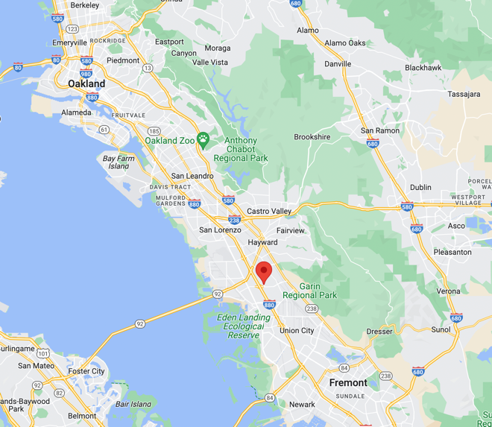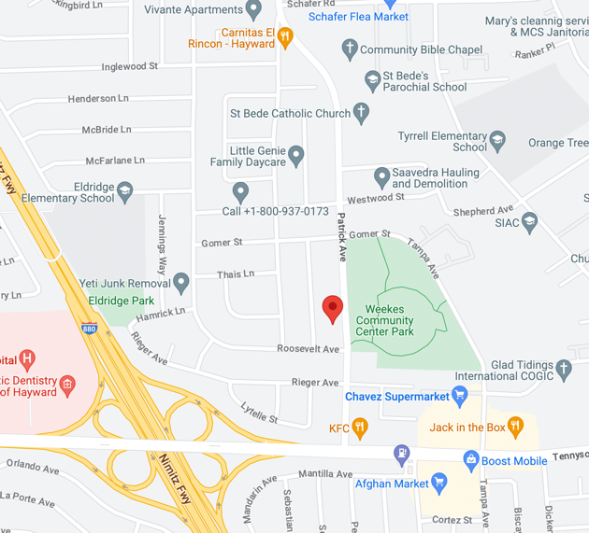
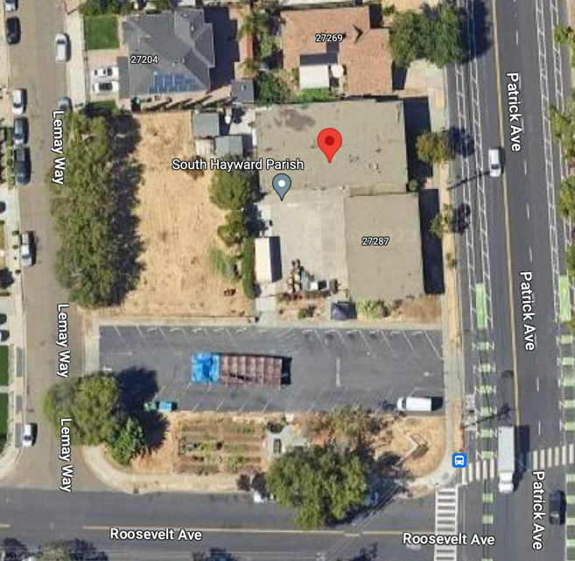 (Google Maps; accessed 26 Sep 2023)

The South Hayward Parish property consists of five (5) individual parcels and the listed mailing address for each parcel is “26236 ADRIAN AVE, HAYWARD, CA 94545”, which is the address of New Bridges. Total lot size (5 combined parcels) = 4,312 sq. Ft/0.94 ac.

PARCEL # | ZONING
Alameda Co. Parcel # 454-65-138 | 6600 CHURCH
Alameda Co. Parcel # 454-65-139 | 1000 VACANT RESIDENTIAL LAND, ZONED 4 UNITS OR LESS
Alameda Co. Parcel # 454-65-140 | 1000 VACANT RESIDENTIAL LAND, ZONED 4 UNITS OR LESS
Alameda Co. Parcel # 454-65-141 | 1000 VACANT RESIDENTIAL LAND, ZONED 4 UNITS OR LESS
Alameda Co. Parcel # 454-65-142 | 1000 VACANT RESIDENTIAL LAND, ZONED 4 UNITS OR LESS

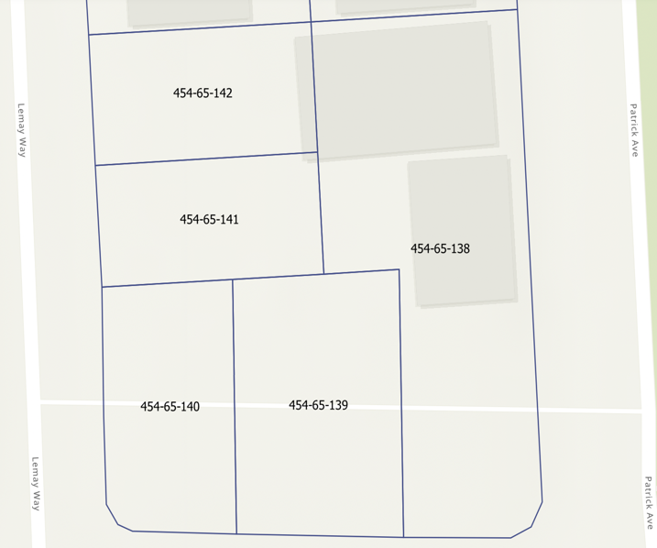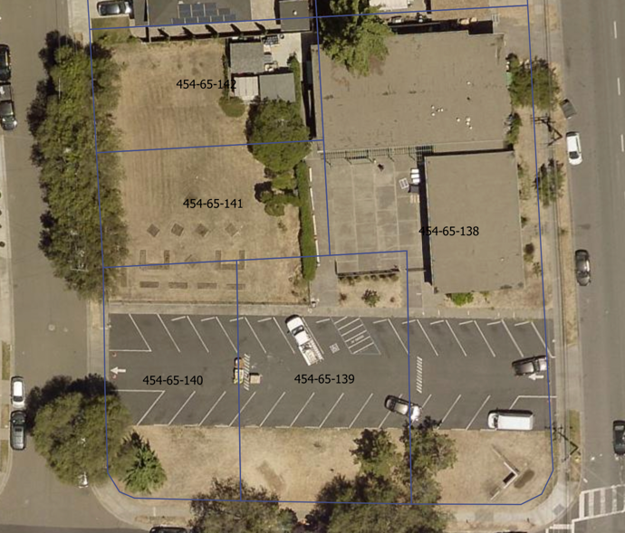
(Alameda County Assessor’s Office; “Parcel Viewer”; accessed 27 Sep 2023)

Forming of New Bridges Presbyterian Church

New Bridges Presbyterian Church (founded in 2011) is located at 26236 Adrian Ave., Hayward CA. (Presbytery of San Francisco; “Report of Committee on Ministry”; Meeting minutes 12 April 2011; accessed 29 Sep 2023) This property was the site of the former Mount Eden Presbyterian Church (MEPC). New Bridges was formed in April 2011 when the WHPC (founded in 1956) and MEPC (founded in 1964) congregations merged and renamed themselves as New Bridges Presbyterian Church. New Bridges is an intercultural congregation that is predominantly African immigrants. (New Bridges Presbyterian Church website; “Our Church”; accessed 27 Sep 2023)

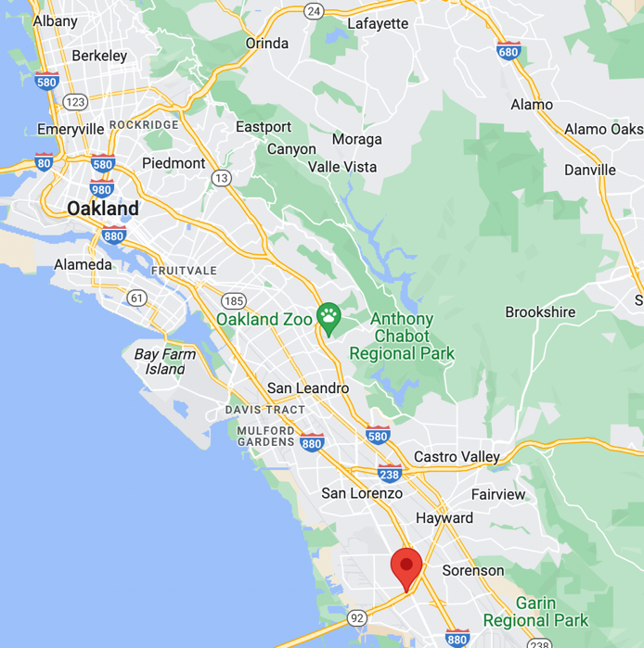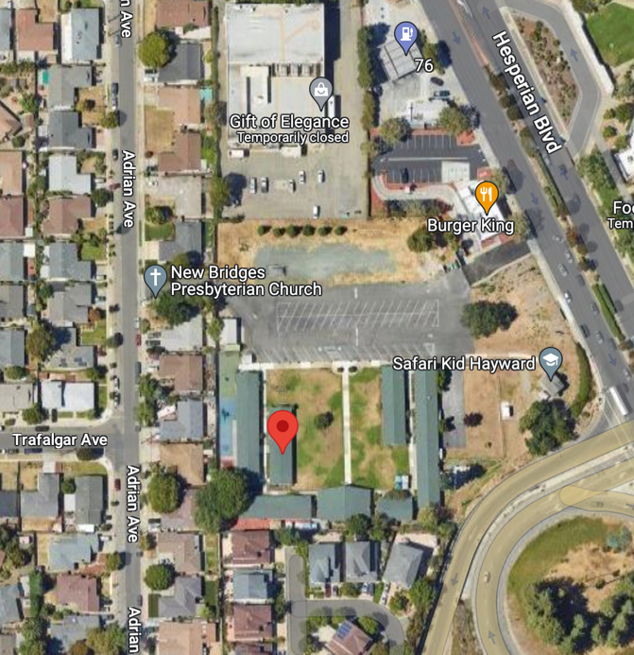
(Google Maps; accessed 26 Sep 2023)

Following the merger of WHPC and MEPC, New Bridges continued to care for the former WHPC/current South Hayward Parish property and participated/supported operate the food pantry ministry and the resource center at the South Hayward Property which was called the “New Bridges Outreach Center”. (“Helping Hayward’s Hungry – The South Hayward Parish”; The Pioneer (CSUEB student newspaper); 22 Oct 2010)

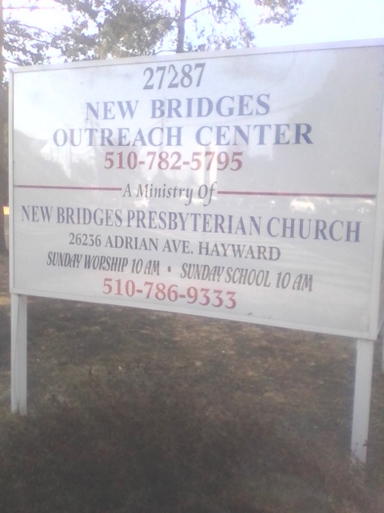
(Yelp photos – South Hayward Parish)

First Presbyterian Church of Hayward

The First Presbyterian Church of Hayward (FPCH) is located at 2490 Grove Way, Castro Valley, CA. FPCH has a multi-pronged community outreach ministry that includes:
Castro Valley church campus: night/winter shelter, resource center, recovery cafe
South Hayward Parish: community food pantry, shelter, resource center, plans for future micro-home village. A 65-year lease (required for county funding) entered with Firm Foundation Community Housing for .24 acres of South Hayward Parish property for micro-housing project (Presbytery of San Francisco, Finance Property Oversight Committee; 9 Aug 2022)

First Presbyterian Church of Hayward (FPCH) began operating a winter shelter and resource center at the FPCH campus in Castro Valley in 2019. Also in 2019, FPCH began managing the food pantry and shelter at South Hayward Parish (Alameda County Board of Supervisors; “Approve Amendment No. 2 To Standard Services Agreement”; dated 19 May 2020)

South Hayward Parish – Property Sale

Prior to 2019, the Session of New Bridges approached the Finance Property Oversight Committee (FPOC) of the Presbytery of San Francisco (PSF) about the possibility of selling the South Hayward Parish property. New Bridges was interested in using the proceeds from the sale of the South Hayward Parish property to make much needed improvements to the New Bridges church facility/property at 26236 Adrian Ave.

The PSF approved site evaluation and appraisal contract for the South Hayward Parish. (Presbytery of San Francisco; “Appendix 3: Contracts for Site Evaluations”; Meeting minutes 12 Feb 2019; accessed 28 Sep 2023)

The PSF approved a lease with FPCH for the South Hayward Parish property
(Presbytery of San Francisco; “Report 1C – Finance Property Oversight Committee - Motion”; Meeting minutes 25 Aug 2020; accessed 28 Sep 2023)

The PSF took over the sales process for the South Hayward Parish property, including fixing the sale price at $1.5M (Presbytery of San Francisco; “Report 1C – Finance Property Oversight Committee – Motion; “To approve that Presbytery of San Francisco take over the sales process for South Hayward Parish site (previously Westminster Hills Presbyterian Church)”; Meeting minutes 12 May 2020; accessed 28 Sep 2023)

In May 2019, PSF approved a motion to approve the sale of the WHPC property. This motion included that the net proceeds from the sale of the WHPC property would go to New Bridges, but “As a condition of this sale, all net proceeds of the sale would be placed in an escrow account for which the Presbytery retains the right to approve any fund distributions on behalf of NBPC.” (Presbytery Meeting Docket; Motion 3, Section IA Finance Property Oversight Committee; 14 May 2019) The South Hayward Parish property had a listed price of $1.6M. (DCG Strategies real estate website; Listing #1057; accessed 27 Sep 2023).

Rather than selling the property to a buyer for market-value, The PSF decided that it would purchase the property for a set price of $1.5M in order to continue the use of the property for ministry purposes in partnership with FPCH. PSF took ownership of the property and shortly after entered a master lease agreement with FPCH. The proceeds from the sale, which were designated to belong to NBPC, are currently in the possession of the PSF, with the distribution to NBPC being completely controlled by the PSF.

Summary/Findings

The expression of white supremacy culture runs throughout this case study. The PSF has used its position of power to control this property sale and use process in a fashion that has taken any significant level of self-determination out of the hands of the New Bridges congregation and its leadership.

Process of discerning/planning/implementation for the former WHPC property: This process appears to primarily involve the PSF and FPCH, lacking any meaningful participation and/or involvement by NBPC. The former WHPC property was linked directly to NBPC (via the remaining WHPC congregation that merged with MEPC to become New Bridges) and the ongoing ministry at the site led by NBPC. The lack of any meaningful voice in determining the future of the WHPC property by the leadership and congregation of NBPC is a significant use of “power” (authority) by the PSF over the voice of NBPC Session and congregation. Following NBPC expressing their interest to sell the property on the open market, the PSF took control of the process, made the determination that the PSF would purchase the property and decided upon the terms of the sale (e.g., PSF setting the sale price), including retaining control over how the proceeds from the sale could be used by NBPC. Documents revealed that FPCH had interest in purchasing the property, but after reviewing other existing financial commitments of FPCH, the PSF did not feel providing a loan to FPCH to purchase the property was prudent at the time. Instead, PSF “purchased” the property (taking on the financial risk rather than FPCH) and then entered a master lease with FPCH to operate the ministry on the property. FPCH was led at the time by Rev. Jake Medcalf (a young, dynamic, white pastor). FPCH also was provided an opportunity to enter a lease for a portion of the property to specifically implement a micro-housing project on the South Hayward Parish property in partnership with First Foundation Community Housing (FFCH), a community housing 501(c)(3). Rev. Medcalf was a former principal with FFCH. Favoritism was made to FPCH (both in planning and financial arrangements) over the expressed interest of NBPC (African immigrant congregation). To this day, there is still anger and frustration within the NBPC congregation from this process.

Control of Sale Proceeds – Withdraw and Use by New Bridges Presbyterian Church: The net proceeds from the sale of the former WHPC property that are to be received by NBPC carries with it a significant element of control by the PSF that appeared to be presented to NBPC without room for negotiation. As a predominantly African immigrant congregation without permanent pastoral leadership, it appears that the NBPC congregation were taken advantage of by the PSF.

The control measures put into place by the PSF for the distribution of the property sale proceeds are an undue burden upon NBPC and has resulted in deep distrust of the PSF by the NBPC congregation and its leadership. At present, no distributions have been made to New Bridges and the PSF retains the “power” in determining how New Bridges can use these funds (white supremacy). (Presbytery of San Francisco; “Report 1C – Finance Property Oversight Committee – Motion; “To approve that Presbytery of San Francisco take over the sales process for South Hayward Parish site (previously Westminster Hills Presbyterian Church)”; Meeting minutes 12 May 2020; accessed 28 Sep 2023)

Additional Notes/References

14 May 2019; Presbytery Meeting Docket, Presbytery of San Francisco;

- Motion to approve sale of Westminster Hills Presbyterian Church property by New Bridges Pres Church; “As a condition of this sale, all net proceeds of the sale would be placed in an escrow account for which the Presbytery retains the right to approve any fund distributions on behalf of NBPC.”

12 May 2020; Presbytery Meeting Minutes, Presbytery of San Francisco

Key Terms of the process:

• Fix the sales price of NEW BRIDGES PRESBYTERIAN CHURCH (NBPC) at $1.5M.

• Upon approval of this motion, the Congregation of NEW BRIDGES PRESBYTERIAN CHURCH will meet at a duly called Congregational meeting, within 45 days of this vote, to consider approval of these terms of sale and approval of the execution of any necessary documents to effect the property transfer.

• Upon approval of the sale of the property by the NEW BRIDGES PRESBYTERIAN CHURCH congregation, and after deducting from the sales price for sales commission (50% of the commission costs), closing costs and all of the other expenses advanced or incurred by PRESBYTERY on behalf of NEW BRIDGES PRESBYTERIAN CHURCH as of the date of the closing of the sale, (which were agreed to by NEW BRIDGES PRESBYTERIAN CHURCH to be repaid to PRESBYTERY at the time of any sale), including appraisal, site evaluations, management cost, maintenance costs, etc. PRESBYTERY will write an interest-bearing note to NEW BRIDGES PRESBYTERIAN CHURCH for the calculated net proceeds of the sale price into that account. Interest will be set at the rate Synod pays for a Mission Deposit Account.

• For the purposes of calculating expenses that NEW BRIDGES PRESBYTERIAN CHURCH will incur in the sale, the effective date of sale relative to expenses incurred will be backdated for 90 days from the execution of all transfer document, in order to reflect the same expenses that would have been incurred by NBPC had the previous motion passed at the February Presbytery meeting, less any retained rent NBPC received after that date. If there is a positive value on the rental income during those 90 days after calculating management and other actual out of pocket expenses of Presbytery during those 90 days, NBPC may retain the positive balance.

• As outlined in the permission to sell that was granted by PRESBYTERY in May 2019, PRESBYTERY must approve any future withdrawals by NEW BRIDGES PRESBYTERIAN CHURCH from that account.

• PRESBYTERY further agrees to take over the Synod loan balance of NEW BRIDGES PRESBYTERIAN CHURCH (approx. $300k) and assume responsibility for all payments due after the effective date of the transfer, and assumes repayment of the loan. When the above documents are duly executed, PRESBYTERY will immediately become the sole and primary trustee of the property in all aspects, as if the property had come to the PRESBYTERY through church closure or other such process. This sole trustee authority includes the ability to decide on any future liquidation of the property should such come to pass, as well as the approval of any site use now or going forward. NEW BRIDGES PRESBYTERIAN CHURCH will sign a document recognizing and approving the transfer of trusteeship. Any rental agreements already in place at the site will be assumed by the PRESBYTERY.

• Upon mutual execution of the transfer trusteeship to the PRESBYTERY, NEW BRIDGES PRESBYTERIAN CHURCH will not incur any further expenses of the site (including management, subsidy, loan interest, taxes, insurance or maintenance/capital costs) after the transaction is completed.

• The sales transaction and all documents effecting that transfer, shall be completed and executed within 60 days of the approval of the NEW BRIDGES PRESBYTERIAN CHURCH’S Congregation of the sale

• Should the building be sold by Presbytery at a price higher than $1.5M within 4 years of the date of transfer of the property to Presbytery from NBPC, any increase in net sales price, less any expenses that Presbytery has incurred for the site in maintaining the site during that time and previous to that time, including staff costs, will accrue to NBPC without interest.

• Should the building be sold by Presbytery, Presbytery cannot sell the building for commercial use nor for market rate housing without the express consent of a subsequent floor vote of the Presbytery.

• Within 90 days, FPOC will propose to Presbytery, for approval, a financial management plan for the site, including whether continuing on with any of the present tenants is viable and recommended. If no such plan is deemed viable, FPOC may propose any alternate plans such as selling the property.

9 August 2022; Presbytery Meeting Docket, Presbytery of San Francisco;

MOTION #1: The Finance and Property Oversight Committee recommends that the Presbytery of San Francisco approve the following: • South Hayward’s recommendation to approve a lease between the Presbytery of San Francisco and Firm Foundations Community Housing for .24 acres of vacant land on the South Hayward Parish site at 27287 Patrick Avenue, Hayward, CA. • A 65-year lease is required to qualify for HomeKey Funding of $2 million and the County of Alameda funding for $463,000 for three years.

Detailed Report: https://www.presbyteryofsf.org/wp-content/uploads/2022/07/FINAL-SECTION-I-DOCKETED-Motions_2022_AUGUST-9.pdf

Appendix 7. Abbreviations

BIPOC - Black, Indigenous, People of Color
COR-BE – Committee on Representation, Belonging and Empowerment
CRE – Commissioned Ruling Elder
FPOC – Finance and Property Oversight Committee
GA – General Assembly
HSPC – High Street Presbyterian Church
LGBTQ – Lesbian, Gay, Bi-Sexual, Transexual and Queer
MVL – Mission, Vision, Leadership
NOM-COR – Nomination and Committee on Representation
NRSVUE – New Revised Standard Version Updated Edition
NWC – New Worshipping Community
PCUSA – Presbyterian Church of the United States of America
PIPH – Primera Iglesia Presbiteriana Hispana
PSF – Presbytery of San Francisco
T-CARE – Truth Commission Assessing Race Equity

Appendix 8. Conversation Circle Summary Notes

Themes
- Insiders/Outsiders
  - Voices aren’t validated; we feel we have no right to speak—not important
  - It took an insider to affirm what they said and validate before they felt heard
  - English is the insider language
  - Language equity, spoken and written—forms are alienating
  - Presbytery works primarily with pastors, not congregations
  - Session members may know what’s going on, but congregations don’t
  - Paternalistic approach to non-English speakers
  - Lack of belonging
  - Desire for someone from Presbytery to visit each congregation each year
  - White pastors seen/heard, BIPOC pastors not
  - Knowledge is power
  - Presbytery meetings should not always be conducted primarily in English, English should be the second language sometimes
  - White churches get more attention from COM
  - Giving money to BIPOC churches is viewed as risk, but white churches are a “good investment”
  - Barriers for BIPOC clergy
- Control of Decision Making
  - Language—we need time to translate, thinking in one language but having to speak in another motivates people to stay silent
  - Low participation: barriers = other commitments, language issues, timing of meetings
  - Money decisions—lack of transparency
  - White pastors seen/heard, BIPOC pastors not; presbytery has relationship with pastors, not congregations
  - Are processes trauma inducing?
- Rigidity
  - Things move very slowly, lots of bureaucracy
  - Lack of mutual care / mutual aid
  - Lack of belonging
  - Presbytery too comfortable with tradition, doesn’t try anything new
  - Processes hinder creativity, creates chaos, limiting and intimidating
- Accountability Gap
  - Pay equity for pastors of color
  - Support for immigrant pastors (visas, etc.)
  - Current system benefits large, white churches = white centering, white churches are listened to, it’s easy for them to get things through, not so for racial/ethnic and immigrant churches
  - Lack of racial/cultural training/knowledge/sensitivity
  - Both NOM and COM need to be accountable to a BIPOC oversite committee
  - Presbytery needs to show up for churches in need, not powerful, large, affluent churches
  - Urgent issue in racial/ethnic church and Presbytery did not respond in timely manner—what is urgent for congregation of color is not urgent for Presbytery
  - Presbytery communication not reaching smaller churches
  - Presbytery’s mission unclear, seems to be in survival mode
  - What do committees do?
  - Mutual aide—you don’t expect it to be hard when you need help
  - Transparency, lack of communication
  - All committees and staff should be accountable for this info
  - Lack of transparency in accountability
  - Where will the actual commitment come from to move this forward?
- Scarcity in Stewardship
  - Funds available but hard to access
  - Poor churches need/deserve more funds—does Presbytery even see the important work done by these churches? Presbytery needs to go where the need is
  - Lack of willingness to spend money leads to perception that presbytery doesn’t have any money—lack of transparency and accountability
  - Salary disparity
- Conflict Avoidance
  - Observation by a member of a church of color that was not involved in any of the case study situations that case study examples could happen to any church of color at any time, the case studies resonated, vulnerability
  - Microaggression, (sophisticated, delicate discrimination)
  - Can’t have racism conversation on floor of presbytery w/out offending, but can’t move forward w/out that conversation
- Positive Feedback
  - COVID support was appreciated
  - A feeling of acceptance at superficial/symbolic level in a multiracial space—safer (but not safe) than the world around us
  - Perception of access to serving on committees and making key decisions
  - Case studies appreciated—stories that need to be told
  - Themes resonated
  - Need for conversation circles to continue
  - Case studies helpful, appreciated, not judgmental
- Constructive Feedback
  - Sexism, intersectionality not acknowledged
  - Recommendations appreciated, but how to implement?
  - COM and CPM not mentioned, human element ignored
  - The work at Cameron House needs to be mentioned; it is continuing

Additional information provided for inclusion within "Appendix 6b. Primera Inglesia Presbiteriana Hispana and High Street Pres Narrative”

Before the COM approved the arrival of Rev. Linda Gruel as HSPC pastor, the PIPH consistory requested a meeting with the committee. At the meeting, the PIPH consistory requested that the decision be seriously considered. The main reason was because the history between Rev. Gruel and PIPH had been negative.

PIPH supported her going to seminary as well as coming under the care of CPM. As she progressed in her studies, she began to change. She defamed the pastor, the leadership and manipulated a couple of family members who ended up leaving the church along with her.
COM did not take into account the request of the PIPH session, approved that she become pastor of HSPC and the problems were not long in coming. Led by the pastor, they took control of the buildings, put pressure on PIPH to leave the buildings and ultimately ended up dissolving the HSPC church and she relinquished jurisdiction as minister of the PCUSA. In an ideal world, COM should have apologized to the PIPH council for its mistaken action but did not.
The aftermath of bad experiences is still in force in some individuals and families. There was never a healing process. For future experiences like these, it is important to keep in mind that wounds do not heal on their own.

The above definitions adapted from the PCUSA Report of The Special Committee on Racism Truth and Reconciliation (SCRTR) to the 225th General Assembly (2022). https://www.pcusa.org/site_media/media/uploads/oga/special_committtee_on_racism_truth_and_reconciliation_to_225_ga.pdf
Building a Relational Culture, adapted by the City of Seattle Race and Social Justice Initiative, 2021. https://www.ci.seattle.wa.us/documents/Departments/RSJI/Resources/Building-a-Relational-Culture-September-2021-City-of-Seattle-Office-for-Civil-Rights-RSJI.pdf. Accessed 10/24/24.
Recalibrating our Spiritual GPS, Presbytery of the Twin Cities, 2023. https://drive.google.com/file/d/1WhkZzv4OFocgy2YUZjpY2gXBASSTlvTc/view. Accessed 8/24/24.
Crossroads Antiracism and Organizing, Theory of Change. http://crossroadsantiracism.org/theory-of-change/. Accessed 10/24/24.
race forward, https://www.raceforward.org/what-racial-equity-0. Accessed 10/24/24.
Othering and Belonging Institute at UC Berkeley, https://belonging.berkeley.edu/redefining-who-belongs/glossary. Accessed 10/24/24.
We recommend this well-established analysis by Tema Okun for further study. The fifteen characteristics of white supremacy culture are perfectionism, a sense of urgency, defensiveness and/or denial, quantity over quality, worship of the written word, the belief in one “right” way, paternalism, either/or binary thinking, power hoarding, fear of open conflict, individualism, progress defined as more, the right to profit, objectivity, and the right to comfort. https://www.whitesupremacyculture.info/uploads/4/3/5/7/43579015/okun_-_white_sup_culture.pdf original article, accessed Sept 2, 2024. https://www.whitesupremacyculture.info/ This website provides excellent continued conversation on what these characteristics are and are not.
To celebrate, nurture, and serve our communities by our life together in Christ. See appendix for full analysis.
https://www.sutori.com/en/story/gracious-dismissal-timeline--kKVMWy4petH7DxoTpJv8Qbwh
Omnibus Report, August 2024 PSF Meeting, Treasurer’s Report in Consolidated Packet.
Our presbytery is in the unusual position of having an abundance of funds received at the departure of large congregations from the denomination. The presbytery decided to create different “bucket” funds, one of which is a grant fund. The rationale for funding in a grant-based manner was that it would inspire and generate “entrepreneurial” creative ministry and that the granting process would help regional churches learn to work together, building local connections. Money was used as an incentive to further this specific vision.
See Tema’s Okun’s work for a complete list https://www.whitesupremacyculture.info/characteristics.html.
McBride, Ben, “Troubling the Water: The Urgent Work of Racial Belonging, Augsburg Fortress, 2023.
https://www.forbes.com/sites/janicegassam/2022/05/21/4-ways-white- supremacy-harms-humanity/
https://www.nytimes.com/interactive/2024/02/25/us/census-race-ethnicity-middle-east-north-africa.html

